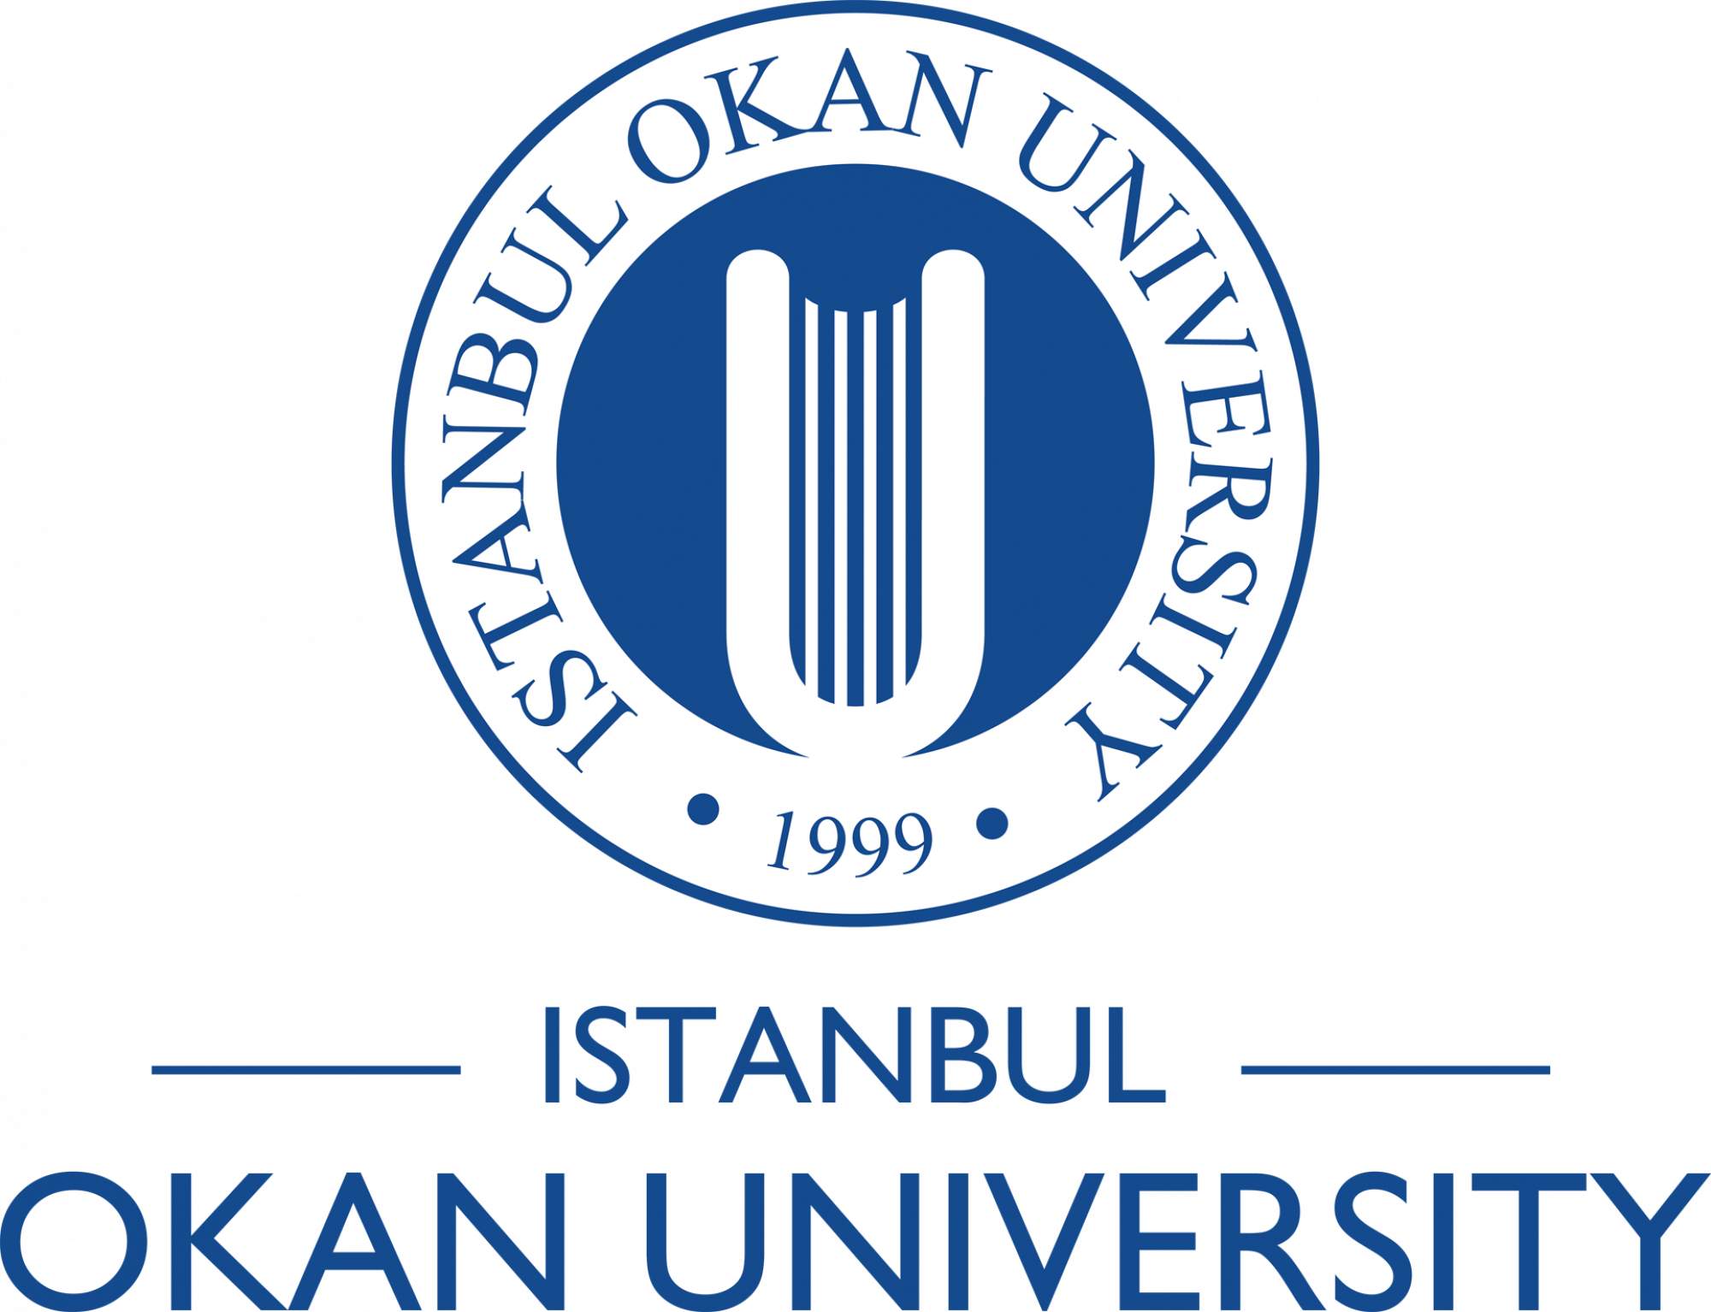

GENDER EQUALITY PLAN

CONTENTS

LIST OF ACRONYMS
LIST OF TABLES
- INTRODUCTION
- RESOURCES
- DATA COLLECTION AND MONITORING
- TRAINING

LIST OF ACRONYMS

CTÖD: Cinsel Tacizi Önleme ve Destek Komisyonu (Commission for Prevention of Sexual Harassment and Support for Victims)

GEP: Gender Equality Plan

IOU: Istanbul Okan University

IOUSP: Istanbul Okan University Strategic Plan 2021-2025 (Note: In references to IOUSP, where necessary, the section/sub-section number is also given in brackets.)

RACGS: Research and Application Center for Gender Studies
LIST OF TABLES

Table 1. Activities of the Center

Table 2. Data Collection and Monitoring Related to IOU Strategic Objective SA4.1.1

Table 3. Data Collection and Monitoring by CTÖD

Table 4. Data Collected and Monitored Annually by RACGS

Table 5. Gender Balance of Academic Staff at Different Levels of the Hierarchy

Table 6. Gender Balance of Project Leaders

- INTRODUCTION

Istanbul Okan University was established by Okan Foundation for Culture, Education and Sports in 1999 and admitted 84 students in 2003. In 2022 the student population in the 10 faculties, 2 vocational schools, the conservatory of music and drama and the Graduate Education Institute has reached 20,000, with 2692 new students registered after YKS 2022 (nationwide university entrance exam).

A staunch follower of the principle of equality of genders as established by Mustafa Kemal Atatürk, the founder of the Republic of Turkey, the university has adhered to the tenets of gender non-discrimination in work-life balance, in leadership and decision-making and in recruitment and career development.

To institutionalize the fundamental strategy of gender equality and prevent gender-based violence, the Commission for Prevention of Sexual Harrasment and Support for Victims (CTÖD) was formed under the authority of the University Rector and started training and monitoring activities as well as providing individual support to victims in 2017. The commission is currently led by the Vice Rector, Prof. Mithat Kıyak.

The Research and Application Center for Gender Studies (RACGS) was formally established in 2017, (Official Gazette 15 December 2017). The aim of the center is to carry out advanced scientific research and to produce information in order to contribute to the establishment of understanding of gender equality in education and academia within all policies and programs. The Center also aims to carry out academic and practical studies to encourage women's participation in politics and economy, to ensure that measures are taken to prevent discrimination and sexual harassment based on gender and sexual orientation, and to carry out training and information activities aimed at raising awareness and sensitivity on these issues. The Center Works with an interdisciplinary approach, taking into account the versatility of gender problems and the interdependence of solutions.

The Center became active in 2020 in cooperation with CTOD, increasing the number of educational activities.

Table 1. Activities carried out by the CTÖD and in cooperation with RACGS

Activities for raising consciousness about gender equality | 2019 & 2020 | 2021- | Target (2025)
Seminars and workshops | 12 | 9 | 10
Training about CTÖD’s purpose and activities | 3 | 1 | 9
Exhibitions | 2 | - | 2

Gender equality was explicitly established as a fundamental value and a constituent of university strategies in the 2021-2025 Istanbul Okan University Strategic Plan, with specific objectives, indicators and action items being defined for the effective realization of those strategies in areas of education, research, social services and internationalization.

In 2022, the Gender Equality Planning Committee was formed under the leadership of Prof. Mithat Kıyak, Vice Rector responsible for Health and Social Affairs and started work towards the preparation of the present plan. The committee included Prof. Zeynep Alemdar, Director of RACGS, Assoc. Prof. Umut Azak, chairperson of CTÖD and other representatives of various units of the university. The first meeting was held on 17 January 2022.

Below the subjects of resources allocated, specific measures taken for data collection and monitoring, and continued training of various target groups are elaborated.

- RESOURCES

  - Human Resources

The Research and Application Center for Gender Studies (RACGS), established in 2017 in conformance with the Turkish Higher Education Law No. 2547, is governed by a Director, a Board of Directors and an Advisory Committee, according to its Bylaw, published in the Official Gazette of the Republic of Turkey dated 27.1.2020, No. 31021. A fundamental mission of this center is to carry out research and disseminate knowledge on gender issues, not only in the university, but also universally.

The Commission for Prevention of Sexual Harassment and Support for Victims (CTÖD), operating under the authority of the University Rector, consists of 10 members representing various academic and administrative units of the university. A three person executive committee carries the responsibility of immediate response to any application to CTÖD and starting the defined procedure for supporting victims. (https://www.okan.edu.tr/ctod/)

By the Strategic Plan, all academic and administrative units are given the responsibility of devoting time and effort for upholding the principle of gender equality, collecting and monitoring data on gender balance, implementing specific training and awareness programs on gender equality and preventing gender discrimination and sexual harassment (IOUSP, (2.5), (2.7.2), (4.2), (4.3), (4.4), (5.3)).

  - Dissemination

Training programs that target students and academic and administrative staff at all levels of the university are implemented for raising gender awareness and prevention of gender discrimination.

Concepts, principles, terminology and rules of prevention of sexual harassment, and support for victims are published in the CTÖD web site (https://www.okan.edu.tr/ctod/). The site also contains the University Bylaw No. YG.OKN.044 originally dated 13.9.2017 and revised on 4.9.2019 governing the formation and operation of CTÖD.

The principle of ‘’Zero tolerance for sexual harassment in Okan University’’ is announced throughout the university with posters, stamps and publications in multiple languages (Turkish, English, Arabic). (IOUSP, 2.7.2) This GEP has been published on the university web site.

- DATA COLLECTION AND MONITORING

In conformance with IOUSP, specific data to be collected and monitored by various academic and administrative units of the university for the purpose of ensuring adherence to the principles of gender equality and preventing discrimination and harassment will be detailed in this section.

Gender Equality has been defined as a strategic objective under the strategic aim referred as Social Awareness / Social Contribution. Aware that universities hold a central position in social development, IOU will establish structures to ensure dominance of respect for human rights, rule of law, awareness of social and gender equality and to lead to socialization of produced knowledge and values with society.

Table 2 presents the data collection and monitoring related to Strategic Objective SA4.1.1: Increasing the number of courses and related activities under the scope of human rights and social awareness.

Table 2. Data Collection and Monitoring Related to IOU Strategic Objective SA4.1.1

Data to be collected and monitored related to SA4.1.1 on gender equality | Responsible body | Frequency | Baseline (2021) | Target (2025)
Number of programs and courses dealing with gender issues. | Academic units | Annual | 8 | 8
Number of extra-curricular seminars, activities such as film screening, etc. aiming to foster gender equality awareness of students; number of participants in each of these activities. | Academic units, Dean of Students, Student Affairs Directorate | Annual | 250 | 360
Number of extra-curricular seminars, activities such as film screening, etc. aiming to foster gender equality awareness of academic and administrative university staff; number of participants in each of these activities. | Academic units, University General Secretary | Annual | 3 | 8

CTÖD monitors its activities and through awareness raising and training activities implemented, aims to reduce the number of cases of harassment victims it responds to. Data collected and monitored annually by CTÖD is presented in Table 2.

Table 3. Data Collected and Monitored Annually by CTÖD

 | 2018-2022
Number of cases of sexual harassment victims applying to CTÖD | 12
Cases referred to psychological consultancy | 4
Disciplinary procedure initiated | 2
Legal procedure initiated | 1

RACGS, in cooperation with the General Secretariat of the University, collects and monitors various categories of data related to gender equality in the Institution. Table 4 presents the gender representation within the University’s various administrative positions and amongst the academic staff.

These data shed light on gender balance in work-life balance, in leadership and decision-making and in recruitment and career development. These are baseline 2021 figures. The target for all figures, to ensure gender balance in leadership and decision-making is to reach 50% at all levels.

Table 4. Data Collected and Monitored Annually by the University General Secretary

 | Female | Male | %Female
Board of Trustees |  | 12 | 0
Executive Committee | 1 | 4 | 20
Senate | 9 | 19 | 47.3
Board of Executives | 4 | 13 | 23.5
Academic Staff | 280 | 223 | 55.7
Administrative Staff | 158 | 98 | 61.7

Table 5 presents data, collected by the Office of the General Secretary, on the gender balance of academic staff at different levels of the academic hierarchy. The table contains the baseline figures from 2021. Monitoring this data and implementing corrective measures is required to ensure the realization of the principle of gender balance in recruitment and career progression

Table 5. Gender Balance of Academic Staff at Different Levels of the Hierarchy

Hierarchical level | Female | Male | % Female
Research Assistant | 18 | 4 | 81.8
Instructor | 43 | 28 | 60.6
Instructor, PhD | 2 | 19 | 9.5
Assistant Professor | 124 | 92 | 57.4
Associate Professor | 12 | 22 | 35.3
Professor | 38 | 58 | 39.6

The RACGS monitors data on research activities as well, and Table 6 presents data on the patent applications, project applications as well as ongoing projects. While the patent applications all came from male applicants, the gender equality in the Project applications and the gender balance in ongoing projects is ensured.

Table 6. Project Leaders

 | Female | Male | % Female
Project Applicant | 84 | 86 | 49
Ongoing Projects | 135 | 139 | 49
4. TRAINING

IOUSP stipulates measures to raise awareness on gender issues and prevent gender discrimination in various points. These are listed below:

(2.5): Gender awareness and respect for gender equality will be studied in the curricula of every university academic unit, together with the subject of ethics. Integration of the gender dimension into research and teaching content will thus be achieved and maintained.

(2.7.2): The organizational culture of IOU is enhanced by implementing training and awareness raising programs for students and academic and administrative staff at all levels to advance gender awareness and prevent gender discrimination.

(4.2): The university mission includes developing projects that aim to dignify humanity, respecting human honour, social responsibility, gender equality and environmental sensitivity.

(4.4.2): A fundamental principle in the education strategy of the university is to implement all measures for respecting gender equality and prevention of any discrimination in all academic and administrative activities.

As noted above in the section on Data Collection and Monitoring, the numbers of educational programs implemented, specific courses opened and extra-curricular seminars, film screenings and other awareness-raising and training activities aiming at students as well as academic and administrative staff, together with the numbers of actual participants in such programs, courses and extra-curricular activities, are established as specific indicators to be monitored and improved in the direction of achieving gender balance and complete non-discrimination.

List of activities are included in Annex 1.

