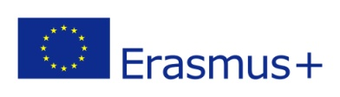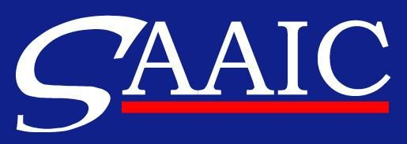

Erasmus Placements in Companies
Placement Description

COMPANY OVERVIEW
NAME OF THE COMPANY | Základná škola Nám. L. Novomeského 2, Košice  Primary School Nám. L. Novomeského 2, Košice
ADDRESS | Nám. L. Novomeského 2, Košice
COUNTRY | Slovakia
WEB PAGE | www.zsnovomke.edu.sk
SHORT INFORMATION ABOUT COMPANY | Primary School Nám. L. Novomeského 2 is situated near the historical centre of Košice. The fact that Košice was the European Capital of Culture in 2013 makes it a very exciting and creative place to live. Our school offers quality education for over 760 children aged between 6 and 15 years. Foreign languages (English, German, French, Spanish, Russian) are taught by fully qualified and experienced teachers. The school has 2 computers rooms, each equipped with 20 computers, and 4 IWBs. It also has 2 gyms and a football pitch for P.E. Our school has a spacious Music Room that can be used for school performances and gatherings. It also offers a variety of after school clubs where children have opportunities to enjoy a wide range of structured and free play activities, including languages, arts and crafts, sports and games, ICT. The school provides Individual Educational Plan for children with learning disabilities. The school canteen offers a snack and a cooked school dinner. Since some of our students are on a gluten -free or diabetes diet, the school canteen also provides dietetic food. In order to increase students´ motivation to learn foreign languages school organizes annual school trips to Great Britain, France and other European countries.  In each class we have a few students with learning disabilities, such as dyslexia, dyscalculia, dysgraphia, and ADHD.  Our school specializes in teaching foreign languages. All our students start to learn English in Year 1. Those who are talented take up another foreign language (German, Spanish, French or Russian) in Year 4, other "less fortunate" students start to study second foreign language when they are in Year 6. By the time they leave our primary school (after finishing Year 9) our students will have reached level A2/B1 in English and level A1/A2 in the second foreign language.  Our school has been engaged in two Comenius Multilateral School Partnerships. It hosted a Comenius Assistant for one year.
CONTACT PERSON | Adriana Pivarnikova
CONTACT DETAILS  (E-MAIL, TEL. NO.) | adapivarnikova@iol.sk, +421 907 285 077
REQUESTED ERASMUS STUDENT PROFILE | Our school has already hosted a Comenius Assistant from 15/09/2013 till 30/06/2014. Our previous Assistant was from France and could speak French, Greek, English and Italian. This time we would prefer a future teacher of English whose first language is English. We will welcome a person with good classroom management skills, someone who is patient, creative and can provide a positive feedback to our students.
FIELD OF STUDIES/PROFESSIONAL AREAS OF INTEREST | We have no specific requests as to the field of studies or professional areas of interest.
TASKS | The assistant will be asked to prepare communicative activities as well as grammar and vocabulary worksheets for students.
REQUIREMENTS (LANGUAGES AND OTHER COMPETENCES) | English is essential. Speakers of other languages are also welcome.
PAYMENT OR OTHER BENEFITS | None
PLACEMENT DURATION | 3 months
PLACEMENT PERIOD  (FROM - TO) | 1st October - 31st May
OTHER INFORMATION | None

