Doctoral Qualifying Exam Process
GRADUATE SCHOOL
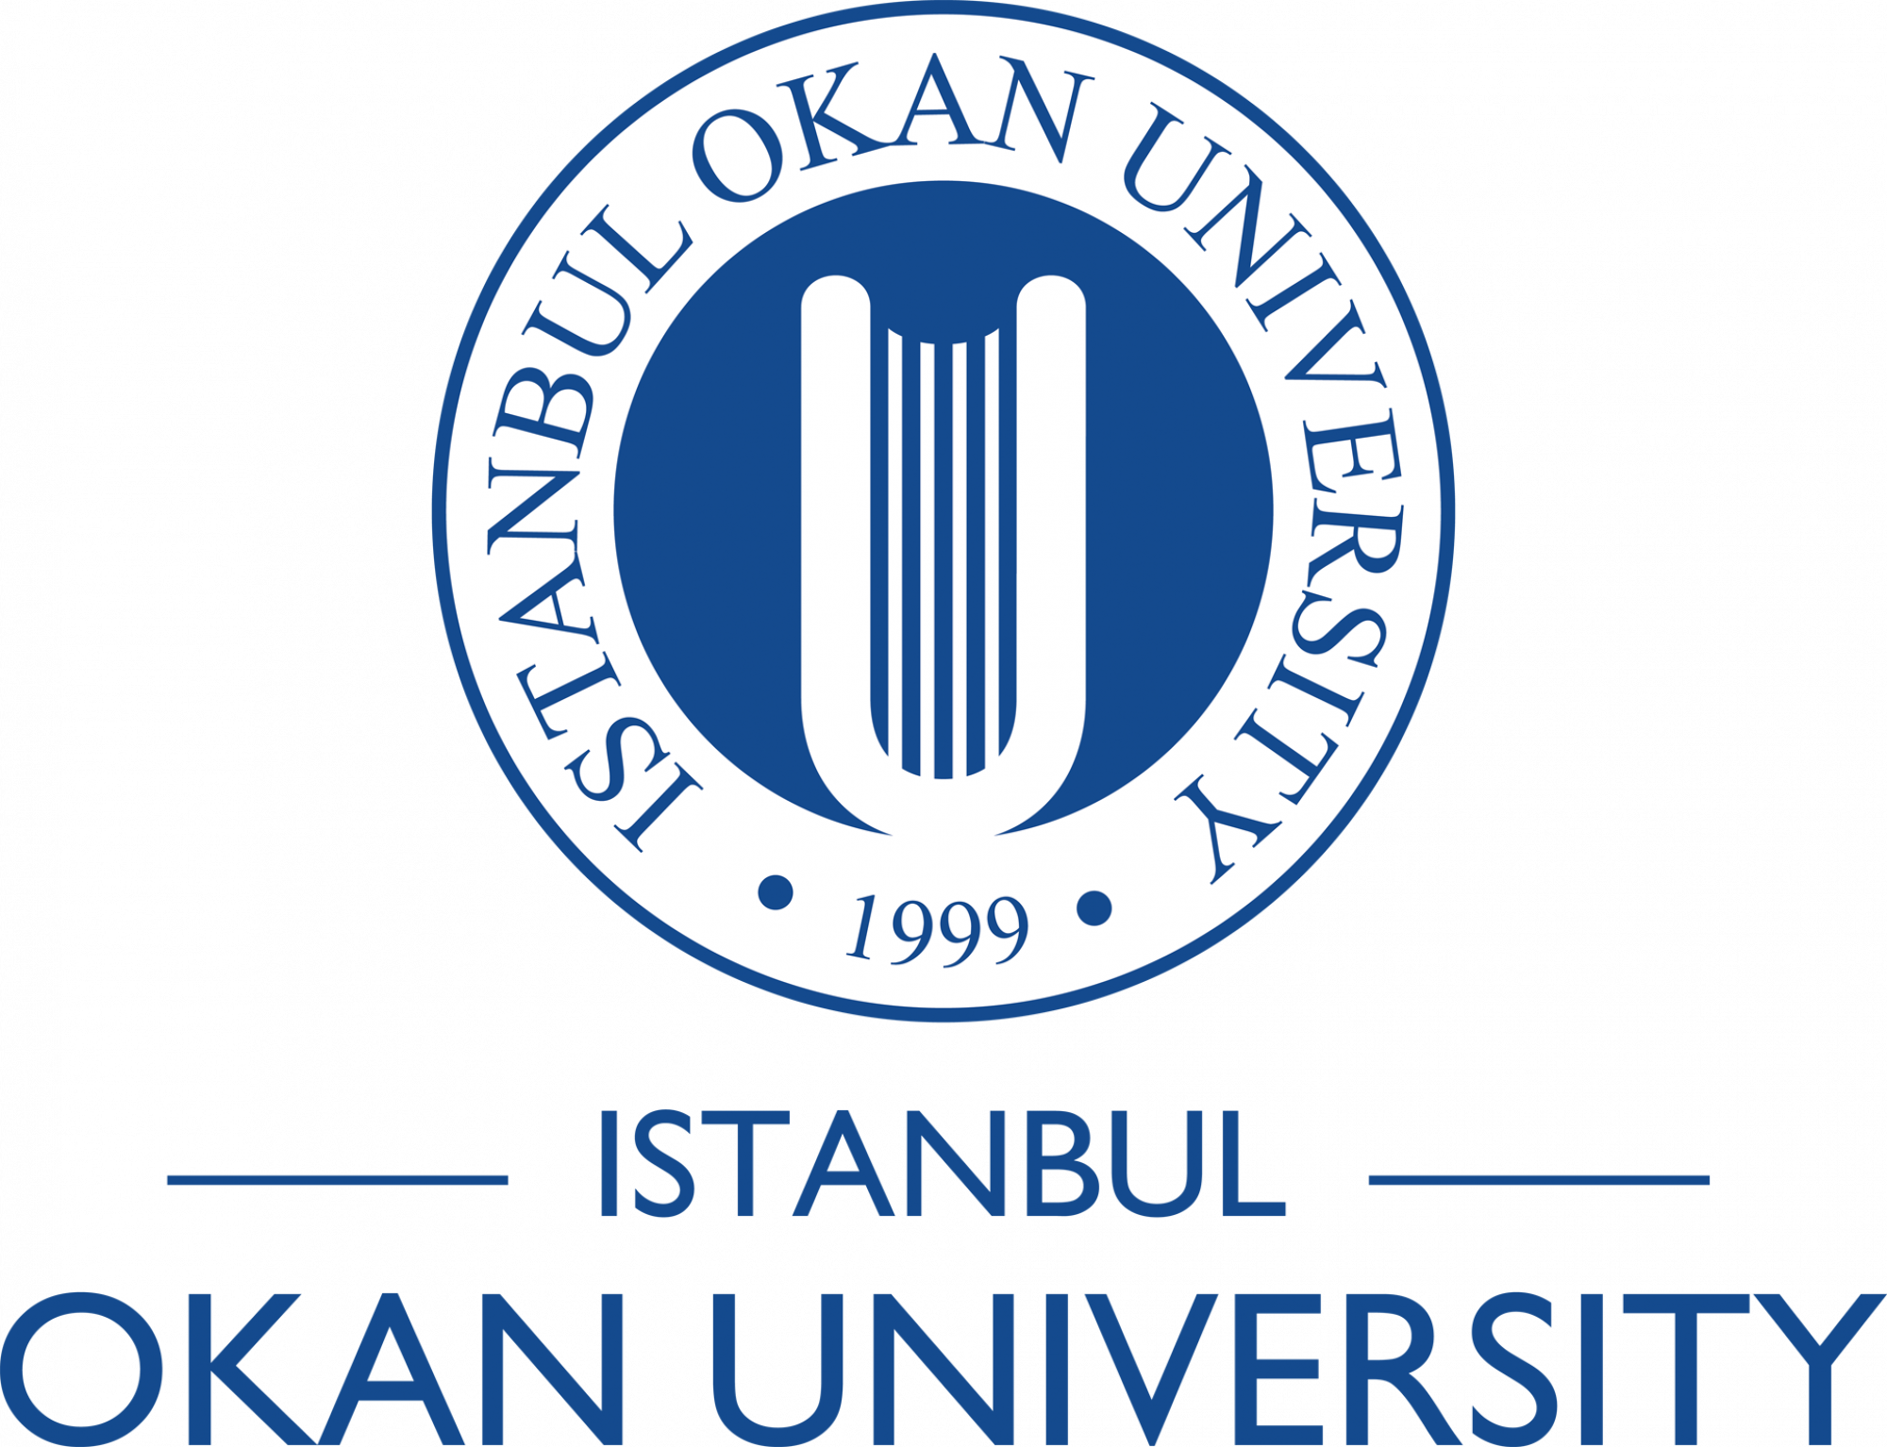
Students who have successfully completed their courses and seminar apply for the Doctoral Qualifying Exam in the following semester.

Students are required to take the written and/or oral qualifying exams by the end of the fifth semester at the latest.

(Oral exam score 50%) + (Written exam score 50%) < 75 points

(Oral exam score 50%) + (Written exam score 50%) ≥ 75 points

>= 60
< 60

>= 60

Management Board of the School.
The dates of the qualifying exams are announced to the Head of the relevant Department.

An examination jury, consisting of faculty members from the relevant field, is formed.
A petition must be submitted to the Graduate Scool Secretariat to take the qualifying exam.

Successful

S
S
S

Admitted to the oral exam.

Unsuccessful

Written
Qualifying Exam

< 60

Not admitted to the oral exam

Students who fail in any course(s) take the exam for the second and final time in the following semester. Students who fail again in this exam will have their affiliation with the university terminated.”

The results are submitted to the graduate school with an official record by the Head of the relevant Department within three days following the qualifying exam.

