Title of the Abstract Prepared for BEFIT 2027
(The First Letter of Each Word in the Title Should Be Capitalized; 14-Point Font, Bold)

First Name Last Name¹, First Name Last Name²* (12-point font, bold)
¹ Department/Division/Research Center
Institute/University/Company
Street Address, City, Postal Code, Country
author@institution.org
²* Department/Division/Research Center
Institute/University/Company
Street Address, City, Postal Code, Country
corresponding.author@institution.org

Abstract (12 font, kalın)
This document serves as the official template for manuscripts to be submitted to the BEFIT 2027 Congress. Abstract submissions must be prepared as an MS Word file in strict accordance with these guidelines.
Presentations may be delivered in either Turkish and English. International participants are required to submit their abstracts in English only. The abstract must be written in both English and Turkish and must not exceed 250 words. Authors are kindly requested to submit their manuscripts as a Word document (Office 2016, 2021, or 2024 editions). The abstract must be formatted in Times New Roman, 12-point font size, except for the title, which must be set in 14-point font. Abstracts should not contain supplementary elements such as graphics, references, or photographs. Utilizing this template, authors must provide the full title of the paper, author affiliations, academic titles, and email addresses, along with a comprehensive abstract that presents the objective, approach, methodology, and key findings of the study.

Keywords: Must not exceed 5 words.
JEL Codes: Must not exceed 5 codes.

Özet (12 font, kalın)
Bu doküman, BEFIT 2027 kongresi için hazırlanacak tebliğler için şablondur. Tebliğ özeti, MS Word dosyası olarak bu talimatlara uygun bir şekilde yazılmalıdır.
Bildiri sunumları Türkçe ve İngilizce olarak yapılabilir. Özetin dili İngilizce ve Türkçedir. Özet bölümü 250 kelimeyi geçmemelidir. Lütfen tebliğinizi Word dokümanı (Office 2016, 2021 veya 2024) olarak gönderiniz. Özetler Times New Roman formatında ve 12 font büyüklüğünde olmalıdır. Sadece başlık 14 font büyüklüğünde yazılacaktır. Özetler; grafik, referans ve fotoğraf vb. ekleri içermemelidir. Yazarlar bu şablonu kullanarak ilgili tam bildiri başlığı, yazarların adres, unvan, e-maillerini ve çalışmanın amacı, yaklaşımı, yöntemi, sonuçlarını içeren özetlerini yazmalıdır.
Anahtar kelimeler: 5 taneden fazla olmamalıdır.
JEL Kodları: 5 taneden fazla olmamalıdır.

- Introduction
In-text citations must follow APA 7 style (American Psychological Association, 7th edition). Citations must be written in 10-point Times New Roman. For further details, please refer to the examples provided in the REFERENCES section of this document.
1.1 In-Text Citation
One author: Use either (Author’s Surname, Year) or Author’s Surname (Year).
Two authors: Use (First Author’s Surname & Second Author’s Surname, Year).
Three or more authors: Use the first author’s surname followed by “et al.” (e.g., Author’s Surname et al., Year).
Direct quotations: Quotations of fewer than 40 words must be incorporated into the text within double quotation marks and must include the relevant page number.

Full papers must be between 4,000 and 7,000 words, including the title, abstract, keywords, main text, all text appearing in tables and figures, references, and appendices. Subheadings must be written in 12-point, bold Times New Roman, with an initial capital letter. The main text must be written in 11-point Times New Roman.

Papers must be prepared in A4 format, with 2.5 cm margins on all sides. Headers and footers should be positioned 1.6 cm from the edge of the page.

All paragraphs must be single-spaced, with a 1 cm first-line indent. Additional spacing should be used only before and after headings and subheadings. No extra spacing should be inserted between paragraphs. Use single-line spacing throughout the text. Please use this page as provided without changing its page layout, paragraph formatting, or font settings.

- Literature Review

The literature review is illustrated below using examples of in-text citations for works authored by one, two, and three or more authors.

Economic growth and institutional transformation require coordinated changes in both macro-level institutional structures and micro-level organizational dynamics. Examining the historical and social dimensions of economic change, North (2005) argues that institutional perceptions and rules must evolve over time to achieve sustainable development. Empirically demonstrating the decisive role of institutional quality in macroeconomic performance, Acemoglu et al. (2005) found that inclusive institutions that protect property rights are among the main drivers of long-term economic growth. However, the success of these macro-level institutional and economic reforms at the organizational level is directly linked to the ability of an organization’s human resources to adapt to this process. Addressing how macro-level structures are reflected in the workplace, Robbins and Judge (2024) emphasize that the effective management of organizational behavior in the modern business environment enhances employee motivation and, consequently, an organization’s capacity for strategic adaptation.

- Data and Methodology

3.1 Equations
Each equation should be presented on a separate line, with one blank line above and below it. Equations should be clearly written, and all symbols and terms used should be explained in the text.

Equations should be left-aligned and numbered on the same line, as illustrated in Equations (1) and (2) below.

$$lninf_{it}=α_{i}+β_{i} rate_{it}+ε_{it}$$ | (1)

$${GDP}_{it}=α_{0it}+β_{1it}GCF+β_{2it}LF+β_{3it}ENU+ε_{it}$$ | (2)

- Analysis

4.1 Tables and Figures
Figure and table captions should be sufficiently descriptive to allow the figure or table to be understood without referring to the main text. Figures and tables that are not cited in the text should not be included in the paper. Caption styles for tables and figures are provided in this document. Text appearing in figures should preferably be no smaller than 10 points. Table 1 below is provided as an example.
Table 1. Sample Table Title (10-point font)
Decision Criterion | Programmed Decisions | Non-Programmed Decisions
Types of Decisions | Programmable, routine, general, and predictable | Non-programmable, unique, and requiring innovation
Nature of the decision | Procedure-based and predictable, with clearly defined information and decision-making criteria | Novel and unstructured, involving incomplete information channels and uncertain decision-making criteria
Decision-making strategy | Reliance on rules and calculations | Reliance on creative problem-solving criteria and sound judgement
Decision-making technique | Scientific techniques, capital budgeting, computer-based solutions, and rules | Judgement and intuition

Source: Dessler (2004), p. 57.

Tables and figures should be placed immediately after they are first cited in the text. Tables must not be inserted as images. Images and figures must be provided in high resolution. All tables and figures must be numbered using Arabic numerals. Table titles should be centred above the tables, while figure captions should be centred below the figures. An example is provided in Figure 1.

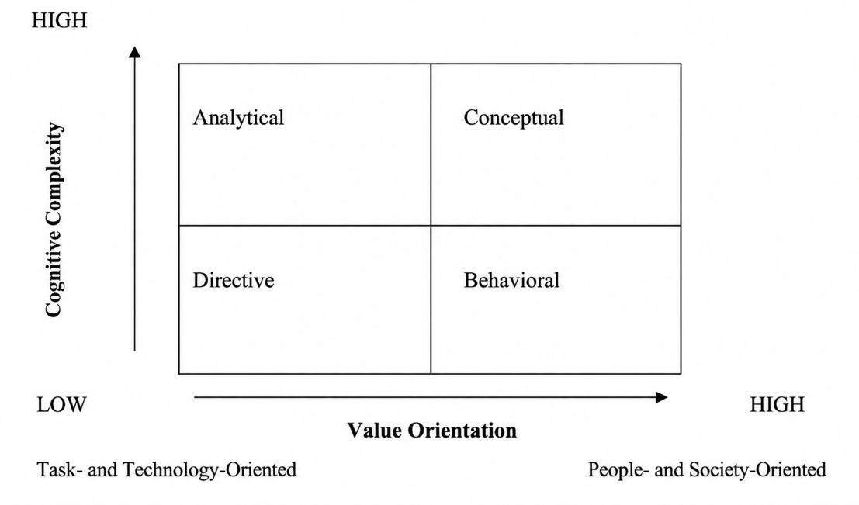

Figure 1. Decision-Making Styles by Dimensions (10-point font)
Source: Kinicki ve Williams (2003), p. 212.
- Conclusion
References
Reference list entries must follow APA 7 style. Include the names of all authors in each reference. Insert a space between the authors’ initials.
Ordering of References: Arrange entries alphabetically by the authors’ surnames.
Book and Article Titles: Capitalize only the first word of the title and subtitle, as well as proper nouns.
Publisher Location: Under APA 7 guidelines, the publisher’s city and country are not included; only the publisher’s name is provided.
Online Sources: Include a DOI or URL at the end of the reference when available.

Please follow the examples provided below when formatting the references.

Acemoğlu, D., Johnson, S., & Robinson, J. A. (2005). Institutions as a fundamental cause of long-run growth. In P. Aghion & S. N. Durlauf (Eds.), Handbook of economic growth (Vol. 1A, pp. 385–472). Elsevier. https://doi.org/10.1016/S1574-0684(05)01006-3.
Benadada, Y., Mhada, F. Z., Boukachour, J., Ouzayd, F., & El Hilali Alaoui, A. (Eds.). (2024). Proceedings of the 7th International Conference on Logistics Operations Management (GOL'24). Springer. https://doi.org/10.1007/978-3-031-68634-4.
Dessler, G. (2004). Management. New Jersey: Pearson Education Ltd.
Kinicki, A. & Williams, B.K. (2003). Management. New York: McGraw-Hill Book Company.
North, D. C. (2005). Understanding the process of economic change. Princeton University Press.
OECD. (2024). OECD Digital Economy Outlook. OECD Publishing. https://doi.org/10.1787/f0b5c251-en.
Podsakoff, P. M., MacKenzie, S. B., Lee, J. Y., & Podsakoff, N. P. (2003). Common method biases in behavioral research: A critical review of the literature and recommended remedies. Journal of Applied Psychology, 88(5), 879–903. https://doi.org/10.1037/0021-9010.88.5.879.
Robbins, S. P., & Judge, T. A. (2024). Organizational behavior (20th ed.). Pearson.
Additional Guidelines
Do not number the headings of the Acknowledgements, Definitions and Abbreviations, References, or Appendices sections. Do not use headers or footers, and do not number the pages.
Acknowledgements
This section is optional. If included, it should be kept as brief as possible.
Definitions and Abbreviations
Where necessary, the Definitions and Abbreviations section should be placed before the reference list. This section should define the metric units, abbreviations, symbols, and Roman letters used in the text.
Appendices
Where necessary, appendices should be placed after the reference list.
Biography
Name of the Presenter – The biography should include the presenter’s educational background in the following order: degree earned, field of study, institution, city, state or country, and year of graduation. The presenter’s main research interests should also be stated. The biography must not exceed 250 words.

