BEFIT 2027 Paper Submission Guidelines

Paper Format
This document provides guidelines for formatting papers submitted to BEFIT 2027. The proceedings will be compiled directly from the electronic documents submitted in this format. Abstracts must be prepared as MS Word documents in accordance with these instructions. Papers may be written in either Turkish or English.

Abstracts may be submitted through the submission form available on the BEFIT 2027 website. Word files should be named using the first author’s name in the following format: FirstName.LastName.1. If the same author submits more than one paper, subsequent files should be named FirstName.LastName.2, and so forth.

The formatting requirements for abstracts and full papers are provided below.

The main title of the paper must be written in 14-point, bold Times New Roman and in uppercase letters.

Abstract (12-point font, bold)
Abstracts must be submitted in both English and Turkish. International participants are required to submit their abstracts in English only. Please submit your paper as a Word document prepared using Microsoft Office 2016, 2021, or 2024. The heading “Abstract” must be written in 12-point, bold Times New Roman, with an initial capital letter. The abstract text must be written in 11-point Times New Roman and must not exceed 250 words.

Abstracts must not contain graphs, references, photographs, or similar supplementary materials. Using this guideline, authors should state the relevant conference track, the full title of the paper, and the corresponding author’s address, academic title, and email address. The abstract should provide a concise account of the study’s purpose, approach, methodology, and findings. No more than five keywords and five JEL codes should be provided.
Full papers should include the following sections:
- Introduction
- Literature Review
- Data and Methodology
- Analysis
- Conclusion
References
Full papers must be between 4,000 and 7,000 words, including the title, abstract, keywords, main text, all text appearing in tables and figures, references, and appendices. Subheadings must be written in 12-point, bold Times New Roman, with an initial capital letter. The main text must be written in 11-point Times New Roman.
Papers must be prepared in A4 format, with 2.5 cm margins on all sides. Headers and footers should be positioned 1.6 cm from the edge of the page.
All paragraphs must be single-spaced, with a 1 cm first-line indent. Additional spacing should be used only before and after headings and subheadings. No extra spacing should be inserted between paragraphs.

Tables and Figures
Figure and table captions should be sufficiently descriptive to allow the figure or table to be understood without reference to the main text. All figures and tables included in the paper must be cited in the text. The caption styles provided in this document should be used for tables and figures. Text appearing in figures should preferably be no smaller than 10 points. Table 1 below is provided as an example.
Table 1. Comparison of Programmed and Non-programmed Decisions (10-point font)
Decision Criterion | Programmed Decisions | Non-Programmed Decisions
Types of Decisions | Programmable, routine, general, and predictable | Non-programmable, unique, and requiring innovation
Nature of the decision | Procedure-based and predictable, with clearly defined information and decision-making criteria | Novel and unstructured, involving incomplete information channels and uncertain decision-making criteria
Decision-making strategy | Reliance on rules and calculations | Reliance on creative problem-solving criteria and sound judgement
Decision-making technique | Scientific techniques, capital budgeting, computer-based solutions, and rules | Judgement and intuition

Source: Dessler (2004), p. 57.

Tables and figures should be placed immediately after they are first cited in the text. Tables must not be inserted as images. All images and figures must be provided in high resolution. All tables and figures must be numbered consecutively using Arabic numerals. Table titles should be centered above the tables, while figure captions should be centered below the figures. An example is provided in Figure 1.

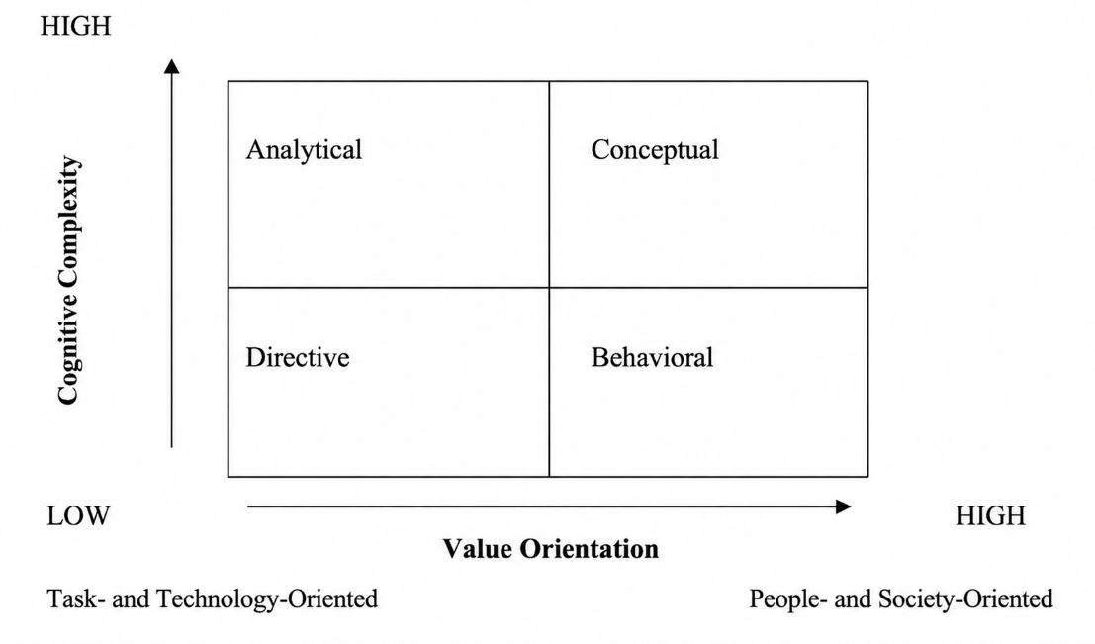

Figure 1. Decision-Making Styles by Dimensions (10-point font)
Source: Kinicki ve Williams (2003), p. 212.

Equations
Each equation should be presented on a separate line, with one blank line above and below it. Equations should be clearly written, and all symbols and terms used should be explained in the text.

Equations should be left-aligned and numbered on the same line, as illustrated in Equations (1) and (2) below.

$$lninf_{it}=α_{i}+β_{i} rate_{it}+ε_{it}$$ | (1)

$${GDP}_{it}=α_{0it}+β_{1it}GCF+β_{2it}LF+β_{3it}ENU+ε_{it}$$ | (2)

References

1.3.1. In-Text Citations

In-text citations must follow the APA 7 style (American Psychological Association, 7th edition). Citations must be written in 10-point Times New Roman. For further information, please refer to the examples provided in the REFERENCES section of this document.

In-text citations:
One author: Use either (Author’s Surname, Year) or Author’s Surname (Year).
Two authors: Use (First Author’s Surname & Second Author’s Surname, Year).
Three or more authors: Use the first author’s surname followed by “et al.” (e.g., First Author’s Surname et al., Year).
Direct quotations: Quotations of fewer than 40 words must be incorporated into the text within double quotation marks and must include the relevant page number.

1.3.2. Reference List Format
Reference list entries must follow APA 7 style. Include the names of all authors in each reference. Insert a space between authors’ initials.
Ordering of References: Arrange entries alphabetically by the authors’ surnames.
Book and Article Titles: Capitalize only the first word of the title and subtitle, as well as proper nouns.
Publisher Location: Under APA 7 guidelines, the publisher’s city and country are not included; only the publisher’s name is provided.
Online Sources: Include a DOI or URL at the end of the reference when available.
Please follow the examples provided below when formatting references.

Acemoglu, D., Johnson, S., & Robinson, J. A. (2005). Institutions as a fundamental cause of long-run growth. In P. Aghion & S. N. Durlauf (Eds.), Handbook of economic growth (Vol. 1A, pp. 385–472). Elsevier. https://doi.org/10.1016/S1574-0684(05)01006-3.
Benadada, Y., Mhada, F. Z., Boukachour, J., Ouzayd, F., & El Hilali Alaoui, A. (Eds.). (2024). Proceedings of the 7th International Conference on Logistics Operations Management (GOL'24). Springer. https://doi.org/10.1007/978-3-031-68634-4.
North, D. C. (2005). Understanding the process of economic change. Princeton University Press.
OECD. (2024). OECD Digital Economy Outlook. OECD Publishing. https://doi.org/10.1787/f0b5c251-en.
Podsakoff, P. M., MacKenzie, S. B., Lee, J. Y., & Podsakoff, N. P. (2003). Common method biases in behavioral research: A critical review of the literature and recommended remedies. Journal of Applied Psychology, 88(5), 879–903. https://doi.org/10.1037/0021-9010.88.5.879.
Robbins, S. P., & Judge, T. A. (2024). Organizational behavior (20th ed.). Pearson.
Additional Guidelines
Do not number the headings for the Acknowledgements, Definitions and Abbreviations, References, or Appendices sections. Do not use headers or footers, and do not number the pages.
Acknowledgements
This section is optional. If included, it should be kept as brief as possible.
Definitions and Abbreviations
Where necessary, the Definitions and Abbreviations section should be placed before the reference list. This section should define the metric units, abbreviations, symbols, and Roman letters used in the text.
Appendices
Where necessary, appendices should be placed after the reference list.

