 |  |  |  | T.C.
 |  | 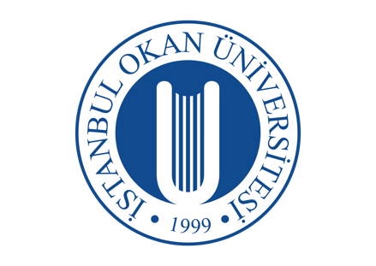 |  | İSTANBUL OKAN UNIVERSITY
 |  |  |  | FACULTY OF DENTISTRY |  | 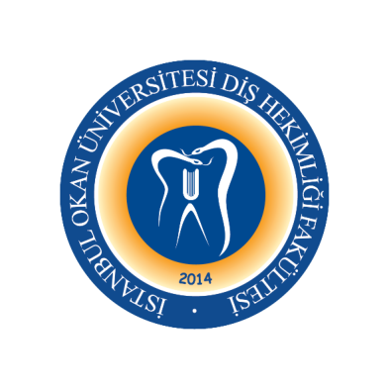
 |  |  |  | 2023-2024 ACADEMIC YEAR
DEPARTMENT: |  |  |  | DEPARTMENT OF ORAL AND MAXİLLOFACİAL SURGERY  DEPARTMENT OF PROSTHODONTICS  DEPARTMENT OF PERIODONTOLOGY
COURSE CODE and NAME: |  |  |  | DENT 519 IMPLANT TREATMENT IN DENTISTRY
RESPONSIBLE FACULTY MEMBER: |  |  |  | Prof. Dr. Gonca KELEŞ
CLASS: |  |  |  | 5. CLASS
SEMESTER / YEAR: |  |  |  | FALL-SPRING SEMESTER (9-10. SEMESTER)
COURSE DAY: |  |  |  | THURSDAY
COURSE HOURS: |  |  |  | 13.30-14.20
 | WEEK |  | DATE |  | DENT 405 PERIODONTOLOGY II THEORETICAL COURSE TOPICS |  | FACULTY MEMBER DELIVERING THE COURSE
Face to Face | 1. WEEK |  | 06.09.2023 |  | Design of Implants / Biomechanics / Osseointegration 1 |  | Assist. Prof. M. Kürşat ALADAĞ
Face to Face | 2. WEEK |  | 13.09.2023 |  | Design of Implants / Biomechanics / Osseointegration 2 |  | Assist. Prof. M. Kürşat ALADAĞ
Face to Face | 3. WEEK |  | 20.09.2023 |  | Surgical Planning in Implant Treatment 1 |  | Assist. Prof. M. Kürşat ALADAĞ
Face to Face | 4. WEEK |  | 27.09.2023 |  | Surgical Planning in Implant Treatment 2 |  | Assist. Prof. M. Kürşat ALADAĞ
Face to Face | 5. WEEK |  | 04.10.2023 |  | Implant Surgery 1 |  | Assist. Prof. M. Kürşat ALADAĞ
Face to Face | 6. WEEK |  | 11.10.2023 |  | Implant Surgery 2 |  | Assist. Prof. M. Kürşat ALADAĞ
Face to Face | 7. WEEK |  | 18.10.2023 |  | Specific Augmentation Methods to Implant Surgery 1 |  | Assist. Prof. Gül Merve YALÇIN ÜLKER
 | 8-9. WEEK |  | 23.10.2023-03.11.2023 |  | 1. MID-TERM EXAM
Face to Face | 10. WEEK |  | 08.11.2023 |  | Specific Augmentation Methods to Implant Surgery 2 |  | Assist. Prof. Gül Merve YALÇIN ÜLKER
Face to Face | 11. WEEK |  | 15.11.2023 |  | Intraoperative and Postoperative Complications  / Success-Survival 1 |  | Assist. Prof. Merve ÇAKIR
Face to Face | 12. WEEK |  | 22.11.2023 |  | Intraoperative and Postoperative Complications  / Success-Survival 2 |  | Assist. Prof. Merve ÇAKIR
Face to Face | 13. WEEK |  | 30.12.2023 |  | Planning and Biomechanics in Implant Prostheses |  | Prof. Dr. Serkan SARIDAĞ
Face to Face | 14. WEEK |  | 07.12.2023 |  | Impression Techniques in Implant Prosthesis |  | Prof. Dr. Serkan SARIDAĞ
Face to Face | 15. WEEK |  | 14.12.2023 |  | Removable Dentures on Implants |  | Prof. Dr. Serkan SARIDAĞ
Face to Face | 16. WEEK |  | 21.12.2023 |  | Fixed Implant Prostheses 1 |  | Prof. Dr. Serkan SARIDAĞ
 |  |  | 25.12.2023-05.01.2024 |  | 2. MID-TERM EXAM
 |  |  | 08.01-19.01.2024 |  | SEMESTER HOLIDAY

 |  | 15.01-19.01.2024 | MAKE-UP EXAM

Face to Face | 17. WEEK | 25.01.2024 | Fixed Implant Prostheses 2 | Prof. Dr. Serkan SARIDAĞ
Face to Face | 18. WEEK | 01.02.2024 | Zero Bone Lose Consept 1 | Prof. Dr. Serkan SARIDAĞ
Face to Face | 19. WEEK | 08.02.2024 | Zero Bone Lose Consept 2 | Prof. Dr. Serkan SARIDAĞ
Face to Face | 20. WEEK | 15.02.2024 | Prosthetic Materials 1 | Prof. Dr. Serkan SARIDAĞ
Face to Face | 21. WEEK | 22.02.2024 | Cemented Restorations | Prof. Dr. Serkan SARIDAĞ
Face to Face | 22. WEEK | 29.02.2024 | Screw Retained Restorations | Prof. Dr. Serkan SARIDAĞ
Face to Face | 23. WEEK | 07.03.2024 | Structure of Peri-implant Tissues | Assist. Prof. Ekin BEŞİROĞLU TURGUT
 | 24-25. WEEK | 11-22.03.2024 | 3. MID-TERM EXAM
Face to Face | 26. WEEK | 28.03.2024 | Implant Applications in Individuals with Periodontal Disease | Assos. Prof. Sibel KAYAALTI YÜKSEK
Face to Face | 27. WEEK | 04.04.2024 | Evaluation of Risk Factors in Implant Applications | Assos. Prof. Sibel KAYAALTI YÜKSEK
Face to Face | 28. WEEK | 11.04.2024 | Soft Tissue Reconstruction Before and After Implant Application 1 | Assist. Prof. Gökçe AYKOL ŞAHİN
Face to Face | 29. WEEK | 18.04.2024 | Soft Tissue Reconstruction Before and After Implant Application 2 | Assist. Prof. Gökçe AYKOL ŞAHİN
Face to Face | 30. WEEK | 25.04.2024 | The Etiology, Findings, Treatment of Peri-implant Diseases 1 | Prof. Dr. Gonca KELEŞ
Face to Face | 31. WEEK | 02.05.2024 | The Etiology, Findings, Treatment of Peri-implant Diseases 2 | Prof. Dr. Gonca KELEŞ
Face to Face | 32. WEEK | 09.05.2024 | Supportive Implant Therapy | Assist. Prof. Nihal ERAYDIN
 |  | 20.05-31.05.2024 | FINAL EXAM WEEK
 |  | 10-24.06.2024 | CONDITION EXAM

