 |  | T.C.
 | 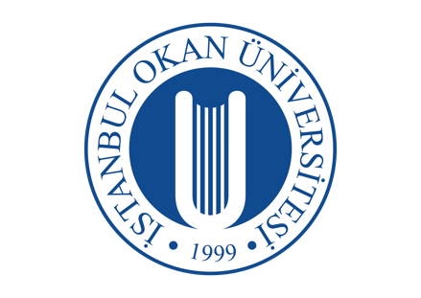 | İSTANBUL OKAN UNIVERSITY
 |  | FACULTY OF DENTISTRY | 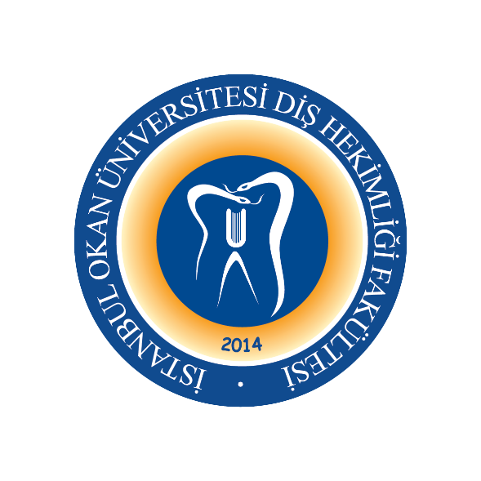
 |  | 2023-2024 ACADEMIC YEAR
DEPARTMENT: |  | PERIODONTOLOGY DEPARTMENT
COURSE CODE and NAME: |  | DENT405 PERIODONTOLOGY II
RESPONSIBLE FACULTY MEMBER: |  | Prof. Dr. Gonca KELEŞ
CLASS: |  | 4. CLASS
SEMESTER / YEAR: |  | FALL-SPRING SEMESTER (8. SEMESTER)
COURSE DAY: |  | FRIDAY
COURSE HOURS: |  | 14.30-15.20
WEEK | DATE | DENT422 RESEARCH METHODOLOGY THEORETICAL COURSE TOPICS Asynchronous | FACULTY MEMBER DELIVERING THE COURSE
1. WEEK | 24.01.2024 | Definition and Characteristics of Scientific Research | Prof. Dr. Gonca KELEŞ
2. WEEK | 31.01.2024 | Objectives of Scientific Research | Prof. Dr. Gonca KELEŞ
3. WEEK | 07.01.2024 | Stages of Scientific Research | Prof. Dr. Gonca KELEŞ
4. WEEK | 14.02.2024 | Subject, Purpose and Importance of Scientific Research | Prof. Dr. Gonca KELEŞ
5. WEEK | 21.02.2024 | Selection of the Problem in Scientific Research | Prof. Dr. Gonca KELEŞ
6. WEEK | 28.02.2024 | The Structure of the Problem in Scientific Research | Prof. Dr. Gonca KELEŞ
7. WEEK | 06.03.2024 | Source Research in Scientific Research | Prof. Dr. Gonca KELEŞ
8-9. WEEK | 11-22.03.2024 | 1. MID-TERM EXAM
10. WEEK | 27.03.2024 | Determination of Hypothesis and Method in Scientific Research | Prof. Dr. Gonca KELEŞ
11. WEEK | 03.04.2024 | Conducting Controlled Experiments in Scientific Research | Prof. Dr. Gonca KELEŞ
12. WEEK | 10.04.2024 | Ethics in Scientific Research | Prof. Dr. Gonca KELEŞ
13. WEEK | 17.04.2024 | Writing Scientific Research Results | Prof. Dr. Gonca KELEŞ
14. WEEK | 24.04.2024 | Writing Scientific Research Results | Prof. Dr. Gonca KELEŞ
15. WEEK | 01.05.2024 | Presentation of Group Study Results | Prof. Dr. Gonca KELEŞ
16. WEEK | 08.05.2024 | Presentation of Group Study Results | Prof. Dr. Gonca KELEŞ
 | 20.05-31.05.2024 | FINAL EXAM WEEK
 | 10-24.06.2024 | CONDITION EXAM

