 |  | T.C.
 | 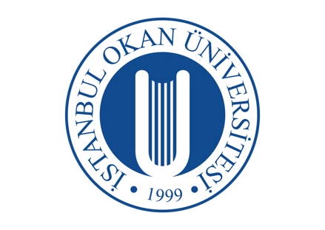 | İSTANBUL OKAN UNIVERSITY
 |  | FACULTY OF DENTISTRY | 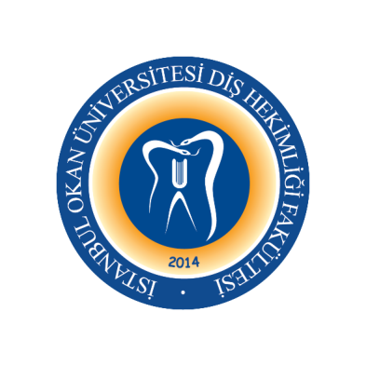
 |  | 2023-2024 ACADEMIC YEAR
ANABİLİM DALI: |  | DENTOMAXILLOFACIAL RADIOLOGY DEPARTMENT
DERS KODU ve ADI: |  | DENT421 – Oral Diagnosis and Radiology II
SORUMLU ÖĞRETİM ÜYESİ: |  | Prof. Dr. Mehmet İLGÜY
SINIF: |  | 4th CLASS
YARIYIL / YIL |  | FALL-SPRING SEMESTER
DERS GÜNÜ: |  | Tuesday
DERS SAATİ: |  | 13.30-14.30
WEEK | DATE | DENT331 - Oral Diagnosis and Radiology II THEORETICAL LECTURE TOPIS | LECTURER
1. WEEK | 5 September 2023 | Radiological Applications in Dentistry | Assoc. Prof. Cansu Büyük
2. WEEK | 12 September 2023 | Cone Beam Computed Tomographic Imaging | Assoc. Prof. Cansu Büyük
3. WEEK | 19 September 2023 | Implant Radiology | Assoc. Prof. Cansu Büyük
4. WEEK | 26 September 2023 | Advanced Imaging Methods | Assoc. Prof. Cansu Büyük
5. WEEK | 3 October 2023 | Odontogenic Cysts | Assoc. Prof. Cansu Büyük | Face to face
6. WEEK | 10 October 2023 | Nonodontogenic Cysts | Assoc. Prof. Cansu Büyük
7. WEEK | 17 October 2023 | Infections of the Jaw Bone | Assoc. Prof. Cansu Büyük | Face to face
8-9. WEEKS | 23 October -  3 November 2023 | 1. EXAM
10. WEEK | 7 November 2023 | Lesions and Other Bone Diseases | Assoc. Prof. Cansu Büyük
11. WEEK | 14 November 2023 | Bone Metabolism Disorders seen in Jaws Fibroosseous | Assoc. Prof. Cansu Büyük
12. WEEK | 21 November 2023 | Herediter and Developmental Bone Anomalies | Assoc. Prof. Cansu Büyük
13. WEEK | 28 November 2023 | Odontogenic Tumors | Assoc. Prof. Cansu Büyük | Face to face
14. WEEK | 5 December 2023 | Nonodontogenic Tumors | Assoc. Prof. Cansu Büyük | Face to face
15. WEEK | 12 December 2023 | Dental approach for Maxillofacial Trauma | Assoc. Prof. Cansu Büyük
16. WEEK | 19 December 2023 | Evaluation of Radiopaque and Radiolucent Lesions | Assoc. Prof. Cansu Büyük | Face to face
 |  | 2. EXAM
 |  | SEMESTER

17. WEEK | 23 January 2024 | Anatomical Changes of Oral Mucosa | Assoc. Prof. Cansu Büyük | Face to face
18. WEEK | 30 January 2024 | Clinical Diagnostic Methods | Assoc. Prof. Cansu Büyük
19. WEEK | 6 February 2024 | Primer and Seconder Lesions of Oral Cavity | Assoc. Prof. Cansu Büyük | Face to face
20. WEEK | 13 February 2024 | Pigmentations of Oral Mucosa and  Perioral Regions | Assoc. Prof. Cansu Büyük
21. WEEK | 20 February 2024 | Changes and Diseases of Tongue | Assoc. Prof. Cansu Büyük
22. WEEK | 27 February 2024 | Changes and Diseases of Lips | Assoc. Prof. Cansu Büyük
23. WEEK | 5 March 2024 | Aphthous Diseases | Assoc. Prof. Cansu Büyük | Face to face
24-25. WEEKS | 11 March –  22 March 2024 | 3. EXAM
26. WEEK | 26 March 2024 | Lichen Planus | Assoc. Prof. Cansu Büyük | Face to face
27. WEEK | 2 April 2024 | Vesiculobullous Diseases | Assoc. Prof. Cansu Büyük | Face to face
28. WEEK | 9 Nisan 2024 | Stomatitis/Fungal Infections | Assoc. Prof. Cansu Büyük
29. WEEK | 16 Nisan 2024 | Precancerous Lesions | Assoc. Prof. Cansu Büyük | Face to face
30. WEEK | 23 Nisan 2024 | Oral Mucosa on Viral and Specific Infections | Assoc. Prof. Cansu Büyük
31. WEEK | 30 Nisan 2024 | Oral Cancers and TNM Classification | Assoc. Prof. Cansu Büyük
32. WEEK | 7 May 2024 | Allergic Reactions and Burning Mouth Syndrome | Assoc. Prof. Cansu Büyük
20 May 2024 | 31 May 2024 | FINAL EXAMS
10 June 2024 | 14 June 2024 | MAKE UP EXAMS

