 |  | T.C.
 | 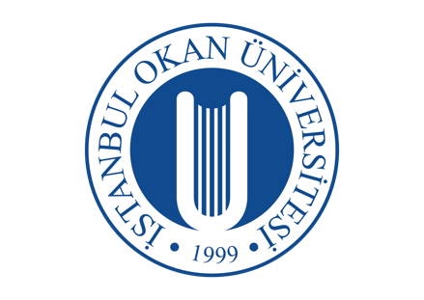 | ISTANBUL OKAN UNIVERSITY
 |  | FACULTY OF DENTISTRY | 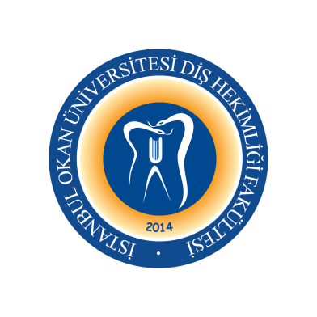
 |  | 2023-2024 ACADEMIC YEAR
DEPARTMENT: |  | RESTORATIVE DENTAL TREATMENT
COURSE CODE AND TITLE: |  | DENT413 RESTORATIVE DENTAL TREATMENT III
LECTURER: |  | Prof. Dr. Haşmet ULUKAPI
CLASS: |  | 4thCLASS
SEMESTER |  | FALL - SPRING SEMESTERS (7th - 8th SEMESTERS)
DAY: |  | Monday
TIME: |  | 13.30-14.20
WEEK | DATE | DENT313 RESTORATIVE DENTAL TREATMENT II THEORETICAL COURSE TITLES | LECTURER
WEEK 1 | 08.09.2023 | Development Abnormalities I | Asst. Prof. Gülşah YENİER
WEEK 2 | 15.09.2023 | Development Abnormalities II | Asst. Prof. Gülşah YENİER
WEEK 3 | 22.09.2023 | Development Abnormalities III | Asst. Prof. Gülşah YENİER
WEEK 4 | 29.09.2023 | Development Abnormalities IV | Asst. Prof. Gülşah YENİER
WEEK 5 | 06.10.2023 | Bleaching in Dentistry - Dental Bleaching  (Home and Power Bleaching) | Asst. Prof. Dr. Merve KÜTÜK ÖMEROĞLU
WEEK 6 | 13.10.2023 | Bleaching in Dentistry  (Microabrasion) | Asst. Prof. Dr. Merve KÜTÜK ÖMEROĞLU
WEEK 7 | 20.10.2023 | Curing Lights and Curing Procedures | Asst. Prof. Dr. Merve KÜTÜK ÖMEROĞLU
WEEK 8 | 27.10.2023 | 1st MID-TERM EXAM WEEKS
WEEK 9 | 03.11.2023 | 1st MID-TERM EXAM WEEKS
WEEK 10 | 10.11.2023 | Laminate Veneer Restorations (Composite Resine) | Asst. Prof. Dr. Işıl DOĞRUER
WEEK 11 | 17.11.2023 | Diastema Closure | Asst. Prof. Dr. Işıl DOĞRUER
WEEK 12 | 24.11.2023 | Inlays | Asst. Prof. Dr. Işıl DOĞRUER
WEEK 13 | 01.12.2023 | Onlays | Asst. Prof. Dr. Işıl DOĞRUER
WEEK 14 | 08.12.2023 | Laminate Veneer Restorations (Ceramic)  (CAD-CAM Aplications I) | Asst. Prof. Melek ÇAM
WEEK15 | 15.12.2023 | Laminate Veneer Restorations (Ceramic)  CAD-CAM Aplications II | Asst. Prof. Melek ÇAM
WEEK 16 | 22.12.2023 | Restorations of Endodontically Treated Teeth | Asst. Prof. Dr. Merve KÜTÜK ÖMEROĞLU
25.12.2023 / 05.01.2024 |  | 2nd MID-TERM EXAM WEEKS
08.01.2024 / 20. 01.2023 |  | SEMESTER HOLIDAY
WEEK 1 | 26.01.2024 | Restorations of Endodontically Treated Teeth  (Fiber Reinforced Restorations) | Asst. Prof. Dr. Merve KÜTÜK ÖMEROĞLU
WEEK 2 | 02.02.2024 | Postoperative Sensitivity I | Asst. Prof. Buket KAYNAR
WEEK 3 | 09.02.2024 | Postoperative Sensitivity II | Asst. Prof. Buket KAYNAR
WEEK 4 | 16.02.2024 | Atraumatic Restorative Treatment | Asst. Prof. Buket KAYNAR
WEEK 5 | 23.02.2024 | Gerontology  (Ozon Application on Caries Therapy I) | Asst. Prof. Melek ÇAM
WEEK 6 | 01.03.2024 | Gerontology  (Ozon Application on Caries Therapy II) | Asst. Prof. Melek ÇAM
WEEK 7 | 08.03.2024 | New Devices in Caries Diognosis | Asst. Prof. Dr. Işıl DOĞRUER
WEEK 8 | 15.03.2024 | 3rd MID-TERM EXAM WEEKS
WEEK 9 | 22.03.2024 | 3rd MID-TERM EXAM WEEKS
WEEK 10 | 29.03.2024 | Indirect Pulp Capping | Asst. Prof. Dr. Gülşah YENİER
WEEK 11 | 05.04.2024 | Direct Pulp Capping | Asst. Prof. Dr. Gülşah YENİER
WEEK 12 | 12.04.2024 | RAMADAN
WEEK 13 | 19.04.2024 | Restoration Repair (Amalgam)  Restoration Repair (Composite)  Fracture of Restoration | Asst. Prof. Buket KAYNAR
WEEK 14 | 26.04.2024 | Caries Removal Techniques | Asst. Prof. Dr. Melek ÇAM
WEEK15 | 03.05.2024 | Caries Removal Techniques | Asst. Prof. Dr. Melek ÇAM
WEEK 16 | 10.05.2024 | Laser in Restorative Dentistry | Asst. Prof. Buket KAYNAR
20.05.2024 /31.05.2024 |  | FINAL EXAM WEEKS
10.06.2024 / 14.06.2024 |  | MAKE-UP WEEK

