 |  |  |  | T.C.
 |  | 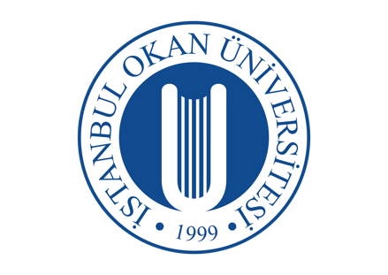 |  | İSTANBUL OKAN UNIVERSITY
 |  |  |  | FACULTY OF DENTISTRY |  | 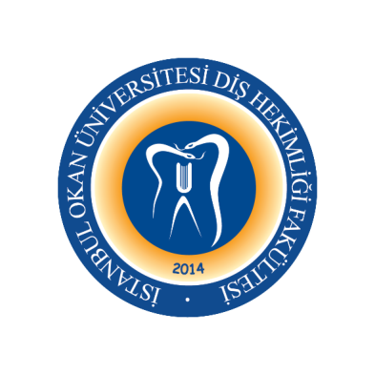
 |  |  |  | 2023-2024 ACADEMIC YEAR
DEPARTMENT: |  |  |  | PERIODONTOLOGY DEPARTMENT
COURSE CODE and NAME: |  |  |  | DENT 405 PERIODONTOLOGY II
RESPONSIBLE FACULTY MEMBER: |  |  |  | Prof. Dr. Gonca KELEŞ
CLASS: |  |  |  | 4. CLASS
SEMESTER / YEAR: |  |  |  | FALL-SPRING SEMESTER (7-8. SEMESTER)
COURSE DAY: |  |  |  | WEDNESDAY
COURSE HOURS: |  |  |  | 13.30-15.20
 | WEEK |  | DATE |  | DENT 405 PERIODONTOLOGY II THEORETICAL COURSE TOPICS |  | FACULTY MEMBER DELIVERING THE COURSE
Face to Face | 1. WEEK |  | 06.09.2023 |  | General Principles of Phase I Periodontal Theraphy  Patient Motivation |  | Assist. Prof. Gökçe AYKOL ŞAHİN
Face to Face | 2. WEEK |  | 13.09.2023 |  | Periodontal Examination and Diagnosis |  | Assist. Prof. Gökçe AYKOL ŞAHİN
Face to Face | 3. WEEK |  | 20.09.2023 |  | Radiographic Aids in the Diagnosis of Periodontal Disease  and Clinical Risk Assessment |  | Assist. Prof. Gökçe AYKOL ŞAHİN
Face to Face | 4. WEEK |  | 27.09.2023 |  | Systemic Anti-infective Theraphy for Periodontal Disease and Determination of Prognosis |  | Assist. Prof. Gökçe AYKOL ŞAHİN
Online | 5. WEEK |  | 04.10.2023 |  | Anti-infective Therapy as Adjunct to Periodontal Treatment |  | Assist. Prof. Ekin BEŞİROĞLU TURGUT
Face to Face | 6. WEEK |  | 11.10.2023 |  | Host Modulation |  | Assist. Prof. Ekin BEŞİROĞLU TURGUT
Online | 7. WEEK |  | 18.10.2023 |  | Trauma from Occlusion |  | Assoc. Prof. Sibel KAYAALTI YÜKSEK
 | 8-9. WEEK |  | 23.10.2023-03.11.2023 |  | 1. MID-TERM EXAM
Online | 10. WEEK |  | 08.11.2023 |  | Splints for Periodontal Theraphy and Occlusal Theraphy |  | Assoc. Prof. Sibel KAYAALTI YÜKSEK
Face to Face | 11. WEEK |  | 15.11.2023 |  | Periodontal Treatment of Medically Compromised Patients |  | Assist. Prof. Ekin BEŞİROĞLU TURGUT
Online | 12. WEEK |  | 22.11.2023 |  | Laser Applications in Periodontology |  | Assist. Prof. Gökçe AYKOL ŞAHİN
Face to Face | 13. WEEK |  | 29.11.2023 |  | Surgical Anatomy of Periodontal Areas |  | Prof. Dr. Gonca KELEŞ
Face to Face | 14. WEEK |  | 06.12.2023 |  | General Principal of Periodontal Surgery and  Periodontal Surgical Instruments |  | Prof. Dr. Gonca KELEŞ
Face to Face | 15. WEEK |  | 13.12.2023 |  | Periodontal Surgical Techniques  Suture Materials and Suture Techniques |  | Assoc. Prof. Sibel KAYAALTI YÜKSEK
Online | 16. WEEK |  | 20.12.2023 |  | Treatment Of Gingival Enlargement |  | Assoc. Prof. Sibel KAYAALTI YÜKSEK
 |  |  | 25.12.2023-05.01.2024 |  | 2. MID-TERM EXAM
 |  |  | 08.01-19.01.2024 |  | SEMESTER HOLIDAY

 |  | 15.01-19.01.2024 | MAKE-UP EXAM

Face to Face | 17. WEEK | 24.01.2024 | The Periodontal Flap | Assoc. Prof. Sibel KAYAALTI YÜKSEK
Online | 18. WEEK | 31.01.2024 | Resective Osseous Surgery and  Aesthetic Crown Lengthening Procedure | Assist. Prof. Nihal ERAYDIN
Face to Face | 19. WEEK | 07.01.2024 | Periodontal Regeneration and  Reconstructive Surgical Techniques | Assist. Prof. Nihal ERAYDIN
Face to Face | 20. WEEK | 14.02.2024 | Biomaterials for Periodontal Regeneration | Assist. Prof. Nihal ERAYDIN
Face to Face | 21. WEEK | 21.02.2024 | Furcation: Involvement and Treatment | Assist. Prof. Ekin BEŞİROĞLU TURGUT
Online | 22. WEEK | 28.02.2024 | Periodontology - Endodontics - Orthodontics - Prosthesis Relationship | Prof. Dr. Gonca KELEŞ
Face to Face | 23. WEEK | 06.03.2024 | Gingival Recession  Periodontal Plastic Surgery I | Assoc.. Prof. Sibel KAYAALTI YÜKSEK
 | 24-25. WEEK | 11-22.03.2024 | 3. MID-TERM EXAM
Face to Face | 26. WEEK | 27.03.2024 | Periodontal Plastic Surgery II | Assoc. Prof. Sibel KAYAALTI YÜKSEK
Online | 27. WEEK | 03.04.2024 | Wound Healing after Periodontal Treatment | Assoc. Prof. Sibel KAYAALTI YÜKSEK
Online | 28. WEEK | 10.04.2024 | Postoperative Care and Periodontal Dressings | Assist. Prof. Nihal ERAYDIN
Online | 29. WEEK | 17.04.2024 | Supportive Periodontal Treatment | Prof. Dr. Gonca KELEŞ
Face to Face | 30. WEEK | 24.04.2024 | Implant Procedures in Periodontology | Prof. Dr. Gonca KELEŞ
Online | 31. WEEK | 01.05.2024 | Dermatoses Affecting Periodontal Tissues | Assist. Prof. Ekin BEŞİROĞLU TURGUT
Face to Face | 32. WEEK | 08.05.2024 | Effects of Smoking on the Periodontal Tissues | Assist. Prof. Ekin BEŞİROĞLU TURGUT
 |  | 20.05-31.05.2024 | FINAL EXAM WEEK
 |  | 10-24.06.2024 | CONDITION EXAM

