 |  | T.C.
 | 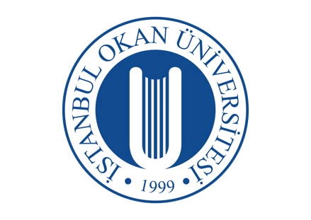 | İSTANBUL OKAN UNIVERSITY
 |  | FACULTY OF DENTISTRY | 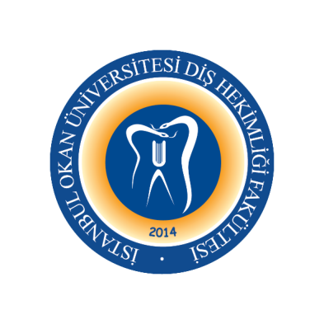
 |  | 2023-2024 ACADEMIC YEAR
ANABİLİM DALI: |  | DENTOMAXILLOFACIAL RADIOLOGY DEPARTMENT
DERS KODU ve ADI: |  | DENT331 – Oral Diagnosis and Radiology II
SORUMLU ÖĞRETİM ÜYESİ: |  | Prof. Dr. Mehmet İLGÜY
SINIF: |  | 3. CLASS
YARIYIL / YIL |  | FALL-SPRING SEMESTER
DERS GÜNÜ: |  | Tuesday
DERS SAATİ: |  | 14.30-15.30
WEEK | DATE | DENT331 - Oral Diagnosis and Radiology II THEORETICAL LECTURE TOPIS | LECTURER
1. WEEK | 5 September 2023 | Introduction to Dentomaxillofacial Radiology | Assoc. Prof. Cansu Büyük
2. WEEK | 12 September 2023 | Intraoral and Extraoral Examination | Assoc. Prof. Cansu Büyük | Face to face
3. WEEK | 19 September 2023 | Radiation Physics | Assoc. Prof. Cansu Büyük
4. WEEK | 26 September 2023 | Radiobiology | Assoc. Prof. Cansu Büyük
5. WEEK | 3 October 2023 | Radiation Protection | Assoc. Prof. Cansu Büyük
6. WEEK | 10 October 2023 | Intraoral Radiography Techniques and Projection Geometry | Assoc. Prof. Cansu Büyük
7. WEEK | 17 October 2023 | Extraoral Radiography Techniques | Assoc. Prof. Cansu Büyük
8-9. WEEKS | 23 October -  3 November 2023 | 1. VISA
10. WEEK | 7 November 2023 | Digital Radiography Principles | Assoc. Prof. Cansu Büyük | Face to face
11. WEEK | 14 November 2023 | Anamnesis, Taking Systemic and Dental History | Assoc. Prof. Cansu Büyük
12. WEEK | 21 November 2023 | Intraoral Radiographic Anatomy | Assoc. Prof. Cansu Büyük | Face to face
13. WEEK | 28 November 2023 | Extraoral Radiographic Anatomy, Soft Tissue Calcifications | Assoc. Prof. Cansu Büyük
14. WEEK | 5 December 2023 | Cardiovascular Diseases | Assoc. Prof. Cansu Büyük | Face to face
15. WEEK | 12 December 2023 | Respiratory Diseases | Assoc. Prof. Cansu Büyük
16. WEEK | 19 December 2023 | Hematologic Disorders I | Assoc. Prof. Cansu Büyük
 |  | 2. VISA
 |  | SEMESTER

17. WEEK | 23 January 2024 | Hematologic Disorders II | Assoc. Prof. Cansu Büyük
18. WEEK | 30 January 2024 | Endocrine Disorders, Pregnancy and Dentistry | Assoc. Prof. Cansu Büyük | Face to face
19. WEEK | 6 February 2024 | Liver Diseases | Assoc. Prof. Cansu Büyük
20. WEEK | 13 February 2024 | Autoimmune Diseases | Assoc. Prof. Cansu Büyük | Face to face
21. WEEK | 20 February 2024 | Renal Diseases and Adrenal Insufficiency | Assoc. Prof. Cansu Büyük
22. WEEK | 27 February 2024 | Dental Management of Chemotherapy, Radiotherapy, and Immunosuppression Conditions | Assoc. Prof. Cansu Büyük | Face to face
23. WEEK | 5 March 2024 | Focal Infection, Antibiotic Prophylaxis | Assoc. Prof. Cansu Büyük
24-25. WEEKS | 11 March –  22 March 2024 | 3. VISA
26. WEEK | 26 March 2024 | Radiographic Quality and Artifacts | Assoc. Prof. Cansu Büyük
27. WEEK | 2 April 2024 | Radiology of Caries and Periodontal Diseases | Assoc. Prof. Cansu Büyük | Face to face
28. WEEK | 9 Nisan 2024 | Paranasal Sinus Diseases and Imaging | Assoc. Prof. Cansu Büyük | Face to face
29. WEEK | 16 Nisan 2024 | Salivary Gland Diseases and Imaging | Assoc. Prof. Cansu Büyük
30. WEEK | 23 Nisan 2024 | Dental Anomalies | Assoc. Prof. Cansu Büyük
31. WEEK | 30 Nisan 2024 | TMJ Diseases and Imaging | Assoc. Prof. Cansu Büyük
32. WEEK | 7 May 2024 | Orofacial Pain | Assoc. Prof. Cansu Büyük
20 May 2024 | 31 May 2024 | FINAL EXAMS
10 June 2024 | 14 June 2024 | MAKE UP EXAMS

