 |  | T.C.
 | 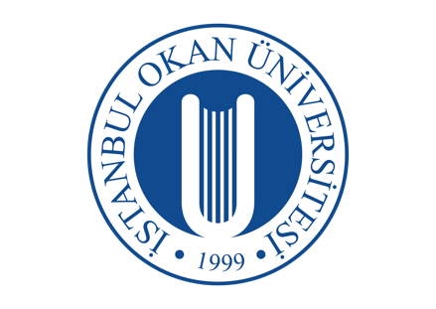 | ISTANBUL OKAN UNIVERSITY
 |  | FACULTY OF DENTISTRY | 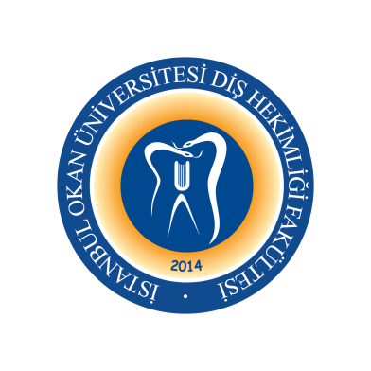
 |  | 2023-2024 ACADEMIC YEAR
DEPARTMENT: |  | RESTORATIVE DENTAL TREATMENT
COURSE CODE AND TITLE: |  | DENT313 RESTORATIVE DENTAL TREATMENT II
LECTURER: |  | Prof. Dr. Haşmet ULUKAPI
CLASS: |  | 3rd CLASS
SEMESTER |  | FALL - SPRING SEMESTERS (5th - 6th SEMESTERS)
DAY: |  | MONDAY
TIME: |  | 15.30-16.20
WEEK | DATE | DENT313 RESTORATIVE DENTAL TREATMENT II THEORETICAL COURSE TITLES | LECTURER
WEEK 1 | 05.09.2023 | Ergonomics in Clinical Practice | Asst. Prof. Dr. Gülşah YENİER
WEEK 2 | 12.09.2023 | Definition of Dental Caries, Hard Tissue Physico-Chemical Properties | Asst. Prof. Dr.Merve KÜTÜK ÖMEROĞLU
WEEK 3 | 19.09.2023 | Determination and Evaluation of DMFT / DFT Indexes  ICDAS-Classification and Caries Classifications,  Indexes, Clinical and Radiographic Evaluation | Asst. Prof. Dr. Gülşah YENİER
WEEK 4 | 26.09.2023 | Etiology of Dental Caries  (Structure and Microorganisms of Oral Biofilm) | Asst. Prof. Dr. Işıl DOĞRUER
WEEK 5 | 03.10.2023 | Etiology of Dental Caries  (Caries and Nutrition) | Asst. Prof. Dr. Işıl DOĞRUER
WEEK 6 | 10.10.2023 | Etiology of Dental Caries  (Saliva) | Asst. Prof. Dr. Işıl DOĞRUER
WEEK 7 | 17.10.2023 | Etiology of Dental Caries  (Oral Immunological Factors) | Asst. Prof. Dr. Buket KAYNAR
WEEK 8 | 23.10.2023 | 1st MID-TERM EXAM WEEKS
WEEK 9 | 30.10.2023 | 1st MID-TERM EXAM WEEKS
WEEK 10 | 07.11.2023 | Predisposing Factors - Faulty Restorations | Asst. Prof. Dr. Melek ÇAM
WEEK 11 | 14.11.2023 | Enamel Caries (Enamel Caries Pathobiology) | Asst. Prof. Dr. Melek ÇAM
WEEK 12 | 21.11.2023 | Dentin Caries (Dentin Caries Pathobiology) | Asst. Prof. Dr. Melek ÇAM
WEEK 13 | 28.11.2023 | Cementum Caries (Cementum Caries Pathobiology) | Asst. Prof. Dr. Melek ÇAM
WEEK 14 | 05.12.2023 | Caries Types in Morphological Structure I  (Pit and Fissure Caries) | Asst. Prof. Dr. Merve KÜTÜK ÖMEROĞLU
WEEK15 | 12.12.2023 | Caries Types in Morphological Structure II  (Flat Surface Caries, Approximal Caries, Root Caries) | Asst. Prof. Dr. Merve KÜTÜK ÖMEROĞLU
WEEK 16 | 19.12.2023 | Caries Types in Morphological Structure III  (White Caries, Acute Caries, Chronic Caries, Secondary Caries, Radiation Caries, Wet-dry Caries) | Asst. Prof. Dr. Merve KÜTÜK ÖMEROĞLU
25.12.2023 / 05.01.2024 |  | 2nd MID-TERM EXAM WEEKS
08.01.2024 / 19. 01.2024 |  | SEMESTER HOLIDAY
WEEK 1 | 23.01.2024 | Definition of Caries Risk and Risk Group Determination / Individual Caries Prophylaxis / Evaluation of Saliva Buffering Capacity, Evaluation of Saliva Flow Rate, Lactobacillus and Mutans Count in Saliva, Individual Preventive Treatment Planning, Determination of Dental Caries Risk | Asst. Prof. Dr. Buket KAYNAR
WEEK 2 | 30.01.2024 | Oral Care Products, Toothpastes and Mouthwashes /  Evaluation of Oral Care Level and  Providing Oral Care Training | Asst. Prof. Dr. Buket KAYNAR
WEEK 3 | 06.02.2024 | Remineralization Agents  (Fluoride, Arginine, Novamin Preparations) | Asst. Prof. Dr. Merve KÜTÜK ÖMEROĞLU
WEEK 4 | 13.02.2024 | Remineralization Agents  (Resin Infiltration Technique and Laser Methods) | Asst. Prof. Dr. Merve KÜTÜK ÖMEROĞLU
WEEK 5 | 20.02.2024 | Preventive Interventions for Bacterial Plaque  (Plaque Disclosing, Mechanical Removal, Antibacterial Agents, Mouthwashes) | Asst. Prof. Dr. Buket KAYNAR
WEEK 6 | 27.02.2024 | Fissure Sealant Application (Non-Invasive), Fissure Sealant Application (Invasive), Preventive Resin Application | Asst. Prof. Dr. Buket KAYNAR
WEEK 7 | 06.03.2024 | Noncarious Dental Hard Tissue Loss  (Abrasion, Abfraction, Atrision, Tooth Erosion) | Asst. Prof. Dr.. Gülşah YENİER
WEEK 8 | 13.03.2024 | 3rd MID-TERM EXAM WEEKS
WEEK 9 | 20.03.2024 | 3rd MID-TERM EXAM WEEKS
WEEK 10 | 26.03.2024 | Noncarious Dental Hard Tissue Loss I  (Abrasion, Abfraction, Atrision, Tooth Erosion) | Asst. Prof. Dr. Gülşah YENİER
WEEK 11 | 02.04.2024 | Dentin Hypersensitivity, Treatment of Dentin Hypersensitivity with Chemical Agents, Laser Treatment of Dentin Hypersensitivity, Treatment of Dentin Hypersensitivity by Restoration | Asst. Prof. Dr. Buket KAYNAR
WEEK 12 | 09.04.2024 | RAMADAN
WEEK 13 | 16.04.2024 | Noncarious Dental Hard Tissue Loss (Treatment)  Vertical Dimension Loss and Treatment | Asst. Prof. Dr. Işıl DOĞRUER
WEEK 14 | 23.04.2024 | PUBLIC HOLLIDAY
WEEK15 | 30.04.2024 | Dental Hard Tissue Loss due to Trauma | Asst. Prof. Dr. Melek ÇAM
WEEK 16 | 07.05.2024 | Tooth Discoloration | Asst. Prof. Dr. Merve KÜTÜK ÖMEROĞLU
20.05.2024 /30.06.2024 |  | FINAL EXAM WEEKS
10.06.2024 /14.06.2024 |  | MAKE-UP WEEK

