 |  | T.C.
 | 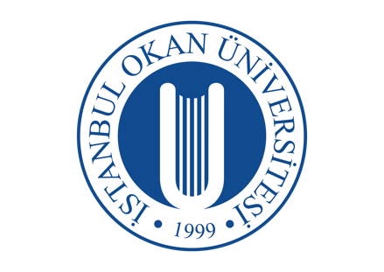 | İSTANBUL OKAN UNIVERSITY
 |  | FACULTY OF DENTISTRY | 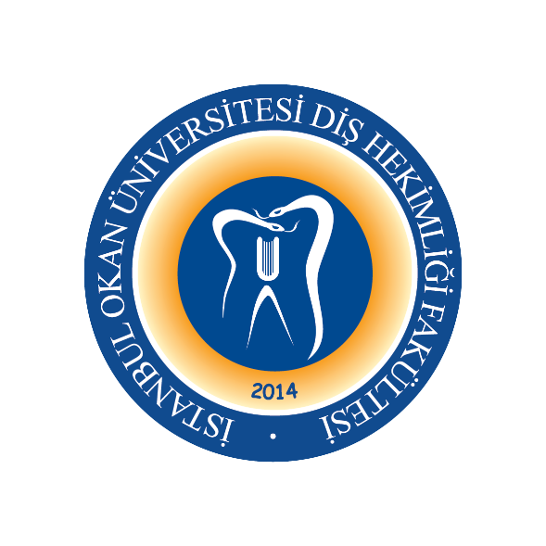
 |  | 2023-2024 ACADEMIC YEAR
DEPARTMENT: |  | PERIODONTOLOGY DEPARTMENT
COURSE CODE and NAME: |  | DENT 305 PERIODONTOLOGY I
RESPONSIBLE FACULTY MEMBER: |  | Prof. Dr. Gonca KELEŞ
CLASS: |  | 3. CLASS
SEMESTER / YEAR: |  | FALL-SPRING SEMESTER (5-6. SEMESTER)
COURSE DAY: |  | Thursday
COURSE HOURS: |  | 13.30-15.20
WEEK | DATE | DENT 305 PERIODONTOLOGY I THEORETICAL COURSE TOPICS | FACULTY MEMBER DELIVERING THE COURSE
1. WEEK | 7.09.2023 | Anatomy, Histology and Development of Periodontal Tissues: Gingiva (face to face) | Prof. Dr. Gonca KELEŞ
2. WEEK | 14.09.2023 | Anatomy, Histology and Development of Periodontal Tissues: Gingiva (face to face) | Prof. Dr. Gonca KELEŞ
3. WEEK | 21.09.2023 | Anatomy, Histology and Development of Periodontal Tissues: Alveolar Bone, Periodontal Ligament (online) | Assist. Prof. Ekin BEŞİROĞLU TURGUT
4. WEEK | 28.09.2023 | Anatomy, Histology and Development of Periodontal Tissues: Cement. Physiology of Periodontal Tissues, Aging and Periodontium (face to face) | Assist. Prof. Ekin BEŞİROĞLU TURGUT
5. WEEK | 5.10.2023 | Etiology of Periodontal Diseases: Biofilm (online) | Assist. Prof. Nihal ERAYDIN
6. WEEK | 12.10.2023 | Etiology of Periodontal Diseases: The Role of Dental Calculus and Other Local Etiological Factors (face to face) | Assist. Prof. Nihal ERAYDIN
7. WEEK | 19.10.2023 | Etiology of Periodontal Diseases: Periodontal Microbiology (online) | Assist. Prof. Nihal ERAYDIN
8-9. WEEK | 23.10-03.11.2023 | 1. MID-TERM EXAM
10. WEEK | 9.11.2023 | Defense Mechanisms of the Gingiva /  Pathogenesis of Periodontal Diseases I (online) | Assist. Prof. Gökçe AYKOL ŞAHİN
11. WEEK | 16.11.2023 | Pathogenesis of Periodontal Diseases II (online) | Assist. Prof. Gökçe AYKOL ŞAHİN
12. WEEK | 23.11.2023 | Pathogenesis of Periodontal Diseases III (online) | Assist. Prof. Gökçe AYKOL ŞAHİN
13. WEEK | 30.11.2023 | Genetic Role of Periodontal Diseases (online) | Assoc. Prof. Sibel KAYAALTI YÜKSEK
14. WEEK | 7.12.2023 | Epidemiology of Periodontal Diseases (online) | Assoc. Prof. Sibel KAYAALTI YÜKSEK
15. WEEK | 14.12.2023 | Classification of Periodontal Diseases (face to face) | Assist. Prof. Nihal ERAYDIN
16. WEEK | 21.12.2023 | Plaque Induced Gingival Diseases (face to face) | Assist. Prof. Nihal ERAYDIN
 | 25.12.2023-05.01.2024 | 2. MID-TERM EXAM
 | 08.01-19.01.2024 | SEMESTER HOLIDAY

17. WEEK | 25.01.2024 | Non-plaque Induced Gingival Diseases (online) | Assist. Prof. Ekin BEŞİROĞLU TURGUT
18. WEEK | 01.02.2024 | Gingival Diseases in Childhood (face to face) | Assist. Prof. Ekin BEŞİROĞLU TURGUT
19. WEEK | 08.02.2024 | Acute Gingical Diseases (face to face) | Assoc. Prof. Sibel KAYAALTI YÜKSEK
20. WEEK | 15.02.2024 | Gingival Enlargement (face to face) | Assoc. Prof. Sibel KAYAALTI YÜKSEK
21. WEEK | 22.02.2024 | The Periodontal Pocket (online) | Assist. Prof. Nihal ERAYDIN
22. WEEK | 29.02.2024 | Periodontitis I (online) | Assist. Prof. Nihal ERAYDIN
23. WEEK | 07.03.2024 | Periodontitis II (face to face) | Assist. Prof. Nihal ERAYDIN
24-25. WEEK | 11-22.03.2024 | 3. MID-TERM EXAM
26. WEEK | 28.03.2024 | Phase I Periodontal Therapy  (Instruments Used in Periodontal Treatment) (face to face) | Assist. Prof. Gökçe AYKOL ŞAHİN
27. WEEK | 04.04.2024 | Instruments Used in Periodontal Treatment (face to face) | Assist. Prof. Gökçe AYKOL ŞAHİN
28. WEEK | 11.04.2024 | General Principles of Instrumentation / Sonic and Ultrasonic (online) | Assist. Prof. Gökçe AYKOL ŞAHİN
29. WEEK | 18.04.2024 | Periodontal Prophylaxis (online) | Assist. Prof. Gökçe AYKOL ŞAHİN
30. WEEK | 25.04.2024 | Impact of Systemic Diseases on the Periodontium (online) | Assist. Prof. Ekin BEŞİROĞLU TURGUT
31. WEEK | 02.04.2024 | Impact of Periodontal Infection on Systemic Health (online) | Assist. Prof. Ekin BEŞİROĞLU TURGUT
32. WEEK | 08.05.2024 | Interactive Case Discussion (online) | Assist. Prof. Ekin BEŞİROĞLU TURGUT
 | 20-31.05.2024 | FINAL EXAM WEEK
 | 10-14.06.2024 | CONDITION EXAM

