SUMMER SCHOOL CALENDAR
16-20 May 2020 - Summer School Course Request Survey
1 June 2020 - Details of the Courses to Offered at Summer School
01-14 June 2020 - Summer School Course Registration and Financial Registration
15 June 2020 – Beginning of Summer School
30 July 2020 – End of Summer School

FOR ISTANBUL OKAN UNIVERSITY STUDENTS
2019-2020 SUMMER SCHOOL GUIDE
16-20 May 2020 Summer School Course Request Survey
For the course/courses that you want to take in the summer school, you can join the website between 16-20 May 2020 by logging into https://ois.okan.edu.tr/auth/login with your username and password. If you have forgotten your password, you can get a new password through the Forgot Password button. If your phone number is not up-to-date, you should inform your current contact information by sending e-mail to ogrenciislerimaillist@okan.edu.tr
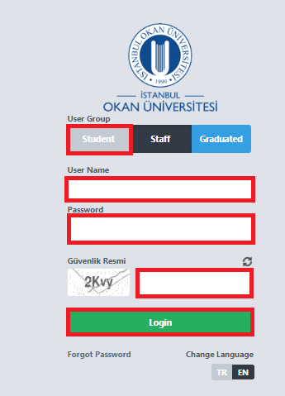
When you enter Ois, select the course / courses that you want to take among the courses you see under the title of “ what course/courses you want to be opened in the 2019-2020 summer school” School" which is on your home page.
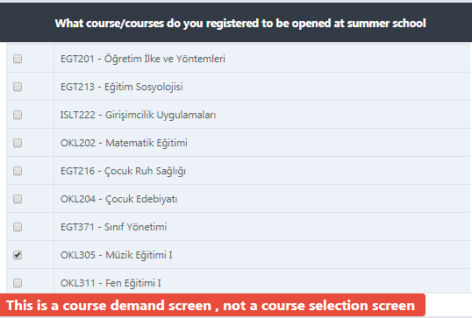
Participation in the survey is important as the courses you select in this survey will determine the formation of the course list that will be opened in the 2019-2020 summer school.

1 June 2020 Details of the Courses to Offered at Summer School
01-14 June 2020 - Summer School Course Registration and Financial Registration
To register for the summer school course, please log in to https://ois.okan.edu.tr/auth/login with your username and password on 1-14 June 2020.

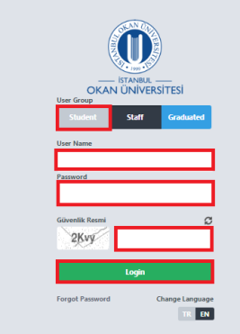
Enter the Course Selection menu under the course operations menu.

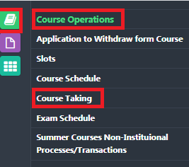
Select the course/courses you want to take in the summer school in the course selection menu and send it to the advisor's approval.
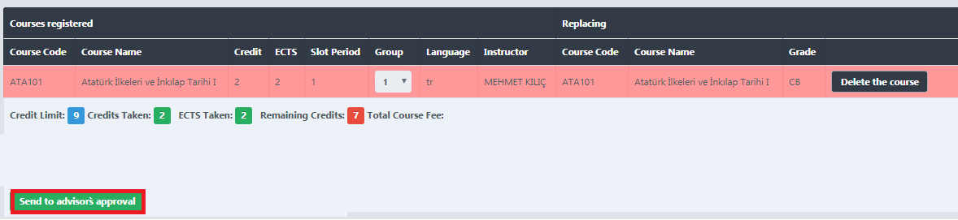
After your advisor approved your course registration, you must make your payment to the account number with the bank information below by writing your student number , name and surname and by stating that it is a summer school fee in the description field.
Receiver name : İSTANBUL OKAN ÜNİVERSİTESİ
Bank name : Vakıfbank
Iban : Tr 87 0001 5001 5804 8012 9625 40
Swıft code : TVBATR2A
https://eodeme.okan.edu.tr/En/Default.aspx you can make credit card payment through the link.

After you pay, you need to load your payment receipt to "choose file" field.
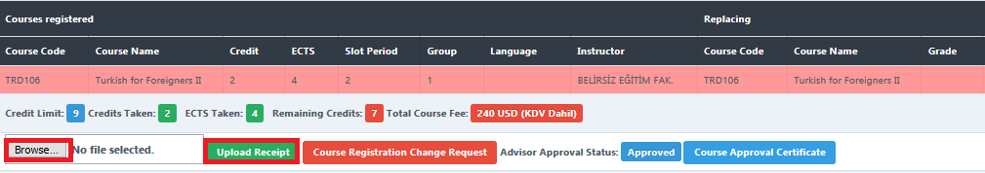

The courses you have taken will be transfered into your transcript in maximum one day after your payment confirmation is received.
Considerations for Summer School Course Selection
Students who want to increase their GPA, although they have been successful in taking notes from the previous semesters, or failed with the lesson/lessons or they have never taken, can make registration
In summer education, a student can take 3 courses or 9 credits from a university or other universities in the summer term.Due to the panndemic, we have enabled you to take additional 2 courses to the number of courses defined in our regulations in online summer school.
The total course load that the student will take from summer education cannot exceed 9 courses or 27 credits for undergraduate programs, 5 courses, or 14 credits for associate degree programs.
The student can also take up to 3 extra courses (including 3rd courses) from summer education only if the following conditions exist:
• a. Completed the fourth semester for associate degree programs and the eighth semester for undergraduate programs,
• b. 9 courses/27 credit load used in summer education,
• c. 95% of the total course credit load required for graduation is the achievement.

15 June 2020 – Beginning of Summer School
30 July 2020 – End of Summer School

