SUMMER SCHOOL CALENDAR
24 June 2021 - Announcement of courses to be opened in summer school
28 June-2 July 2021 - Summer School Course Registration and Financial Registration
5 July 2021 – Beginning of Summer School
27 August 2021 – End of Summer School

FOR ISTANBUL OKAN UNIVERSITY STUDENTS
2020-2021 SUMMER SCHOOL GUIDE

24 June 2021 Announcement of courses to be opened in summer school
28 June-2 July 2021 - Summer School Course Registration and Financial Registration
In order to register for summer school courses, please enter https://ois.okan.edu.tr/auth/login address with your username and password between June 28 and July 2, 2021.
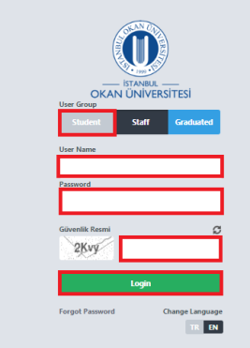
Enter the Course Taking menu under the Course operations menu.
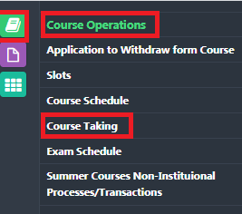
In the course taking menu, select the courses/courses you want to take in the summer school and send them for advisor approval.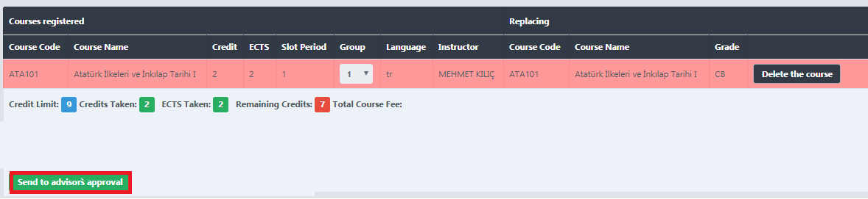
Once your course registration has been approved by your advisor, you must pay for the account number below by stating your student number, first name, surname . You should also state that this payment is a summer school fee
USD account
Receiver name : İSTANBUL OKAN ÜNİVERSİTESİ
Bank name : Vakıfbank
Iban : TR 31 0001 5001 5804 8019 64 5781
Swıft code : TVBATR2A
https://eodeme.okan.edu.tr/En/Default.aspx you can make credit card payment through this e-payment link
After you make a payment, you must upload the receipt that you have paid through the “Select file” field.
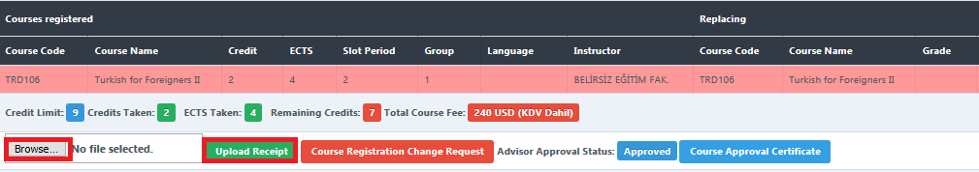
The next day after your payment confirmation is received, the lessons you have taken will be transfered to your transcript.
Considerations regarding Summer School Course Selection
Students who want to increase their GPA can register even though they are successful by taking grades with courses/courses that they have failed or never taken from their lower semesters.
In summer teaching, a student can take 3 courses or 9 credits from a university or other university during a summer semester. In the 2020-2021 Summer School, due to the pandemic, +2 courses were given in addition to 3 courses.
The total course load that the student will receive from summer education cannot exceed 9 courses or 27 credits for undergraduate programs, 5 courses or 14 credits for associate degree programs.
The student can also take up to an additional 3 courses (including lesson 3) from summer teaching only if the following conditions exist;
• If the fourth semester for associate degree programs and the eighth semester for undergraduate programs have been completed,
•If 9 courses / 27 credit loads used in summer teaching,
• If 95% of the total course credit load required for graduation has been achieved
5 July 2021 – Beginning of Summer School
27 August 2021 – End of Summer School

