SUMMER SCHOOL CALENDAR
7-10 June 2023 - Summer School Course Registration and Financial Registration
12 July 2023 – Beginning of Summer School
4 August 2023 – End of Summer School

FOR ISTANBUL OKAN UNIVERSITY STUDENTS
2022-2023 SUMMER SCHOOL GUIDE

07 June 2023 Announcement of courses to be opened in summer school
07-10 June 2023 - Summer School Course Registration and Financial Registration
In order to register for summer school courses, please enter https://ois.okan.edu.tr/auth/login address with your username and password between June 07 and 10, 2023.
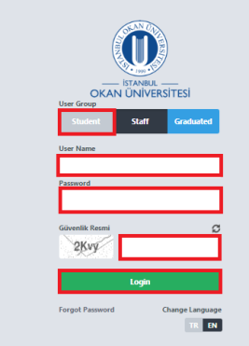
Enter the Course Taking menu under the Course operations menu.
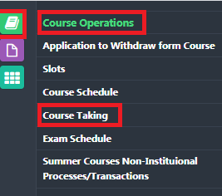
In the course taking menu, select the courses/courses you want to take in the summer school and send them for advisor approval.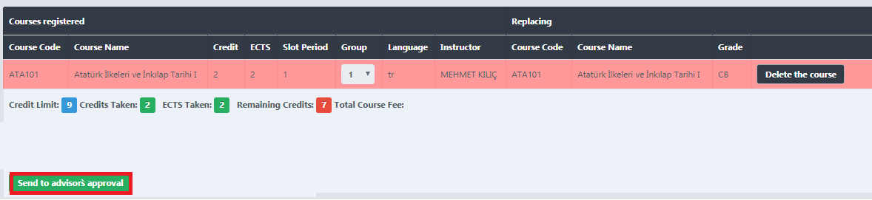
Once your course registration has been approved by your advisor, you must pay for the account number below by stating your student number, first name, surname . You should also state that this payment is a summer school fee
USD account
Receiver name : İSTANBUL OKAN ÜNİVERSİTESİ
Bank name : Halkbank
Iban : TR 55 0001 2001 3980 0058 1005 51
Swıft code : TRHBTR2A
https://eodeme.okan.edu.tr/En/Default.aspx you can make credit card payment through this e-payment link
After you make a payment, you must upload the receipt that you have paid through the “Select file” field.
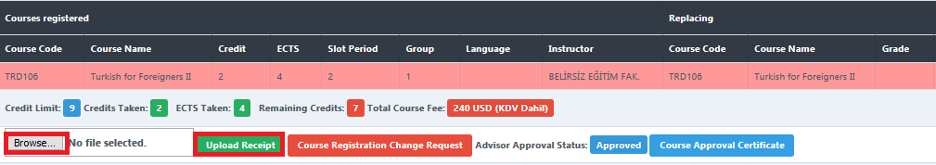
The next day after your payment confirmation is received, the lessons you have taken will be transfered to your transcript.
Considerations regarding Summer School Course Selection
- Students who want to increase their GPA can register even though they are successful by taking grades with courses/courses that they have failed or never taken from their lower semesters.
- In summer teaching, a student can take 3 courses from a university or other university during a summer semester. In the 2022-2023 Summer School.
- The total course load that the student will receive from summer education cannot exceed 9 courses for undergraduate programs, 5 courses for associate degree programs.
- In case the student requests to take courses from the upper semesters, within the scope of Article 28/3 of the Istanbul Okan University Associate Degree and Undergraduate Education and Examination Regulation, "Students who have taken all the courses in the curriculum of the past semesters, who have been successful and have not failed the course, but whose Cumulative Grade Point Average (GPA) is 3.00 and above can take a course from the upper semesters.
The student can also take up to an additional 3 courses (including lesson 3) from summer teaching only if the following conditions exist;
- If the fourth semester for associate degree programs and the eighth semester for undergraduate programs have been completed,
- The limit of 5 (five) courses for Associate Degree programs , 9 (nine) courses for Undergraduate programs should have been used in previous summer education , 9 course credit loads should have been used in summer education,
- • If 90% of the total course credit load required for graduation has been achieved
12 June 2023 – Beginning of Summer School
04 August 2023 – End of Summer School

