  - 2021-2022 ACTIVITIES

A Curriculum Designed to Educate Contemporary and Competent Professionals

ISTANBUL OKAN UNIVERSITY

DEPARTMENT OF BUSINESS ADMINISTRATION

Istanbul Okan University Department of Business Administration

⬥ To provide an interdisciplinary and multidimensional education;

⬥ To equip students with the necessary knowledge and skills to become competent individuals in a rapidly changing world;

To offer modular courses in rich sub-specialization areas aligned with students’ interests and targeted sectors, aiming to shape fundamental managerial and leadership competencies, and to develop students' intellectual and multicultural capabilities.

The Department of Business Administration offers two programs, one in English and one in Turkish. Our faculty consists of eight full-time academic staff members and one lecturer. Among them, one holds the title of Professor, and seven are Assistant Professors.
Istanbul Okan University’s Department of Business Administration prepares students for their future careers with a curriculum enriched by seminars and conferences and an academic staff committed to participatory education. The close interaction and engagement between our faculty members and students also aim to support students’ career development after graduation.
Our educational model enables students to specialize in both core and sub-fields while allowing them to differentiate themselves through minor and double major programs. Through International Exchange and Erasmus+ programs, they can enrich their career journeys. Our Business Strategy Laboratory and Trademaster Finance Laboratory reflect the technological resources available to our students.
Our students benefit from innovative educational solutions such as projects, case studies, industry workshops, mandatory and voluntary internships, field studies, the O’COOP / COOPerative Learning Workplace Training Program, business simulations, and branded courses to support their development.

This year, we are also expecting students who:

⬥ Want to gain the necessary knowledge to continue their lives as effective individuals equipped for the needs of the globalizing world,
⬥ Are excited to learn business and management science theories as well as combine them with the realities of the business world,
⬥ Aim to become socially responsible entrepreneurs and competent professionals with creative, analytical and critical thinking skills,
⬥ Want to receive language education in Chinese, Russian and Arabic in addition to English,
⬥ Are open to gaining experience at universities in the USA and Europe.

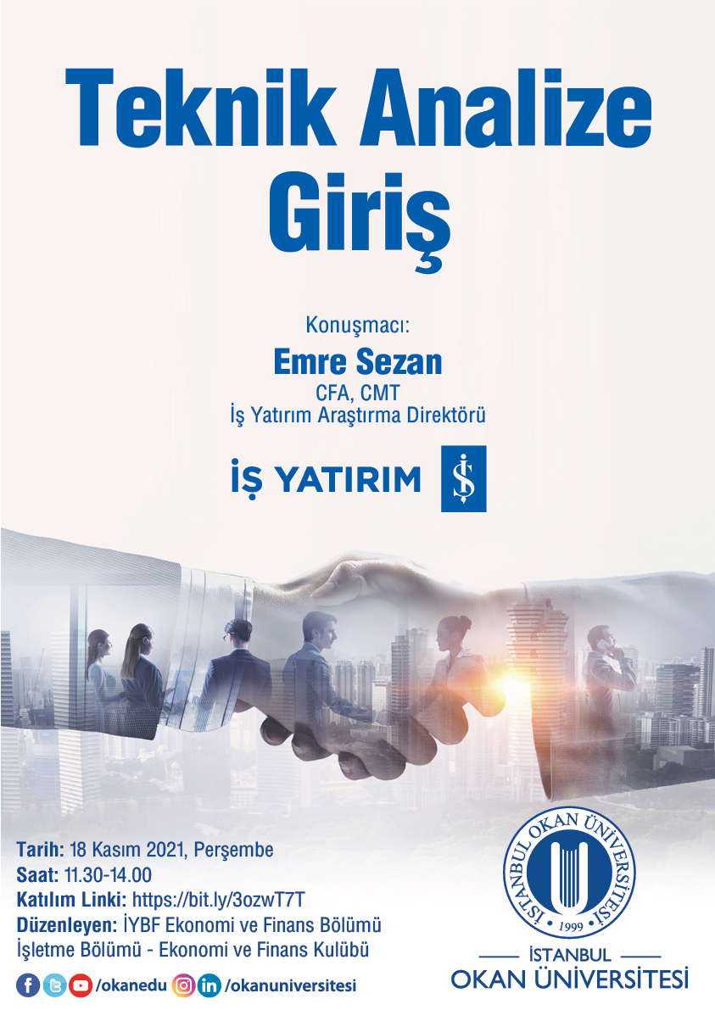
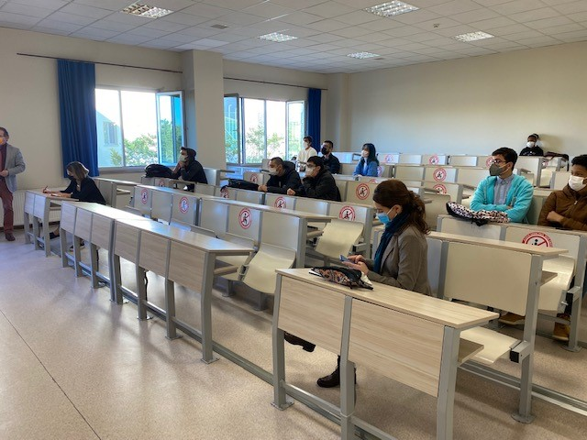
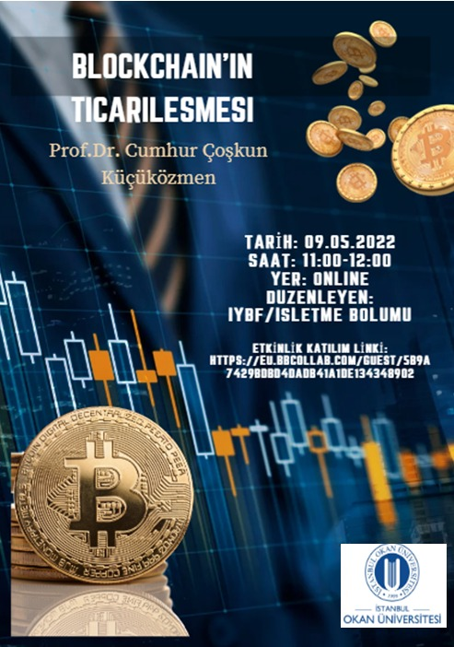
Our university, which is the first Turkish university authorized to grant "HND - High National Diploma", came together with the students of our department and introduced the program in which they will have the right to receive a second bachelor's degree from the university by studying for one more year in the same field at partner universities in countries such as the UK, EU, USA and Canada.

The ‘‘Student Meetings’’ to which all students in our department were invited continued to contribute to the development of our department with the feedback we received from our students this year. Within the scope of the meetings; suggestions and requests were evaluated and the opportunity to see our department from the perspective of the students was provided.

Business Administration Department Events
As the Department of Business Administration, we continued to hold our events in physical and virtual media this year, as we did in previous years.

18.10.2021
Director of Investment, Türkiye İş Yatırım Bankası Emre Sezan – ‘‘Teknik Analize Giriş’’

17.01.2022
A strategy development meeting was held by meeting with relevant stakeholders.

09.05.2022
Prof. Dr. Cumhur Coşkun Küçüközmen – ‘‘Blockchain’in Ticarileşmesi’’

Our department was introduced with the ‘‘Mindfullness Workshop’’ organized by our faculty members for high school students.

The ‘‘13th Trademaster Investment League’’, which was attended by 5 teams within the scope of the Investment and Portfolio Management course, allowed the understanding of the practical use of theoretical information with real-time market data.

Canan Koçer Durmaz, 2021,
21. Yüzyıl Becerileri Bağlamında Yöneticilerin Değişen Rollerinin Çalışan Algılarına Göre İncelenmesi: İstanbul İli Örneği. Karabulut, Ş. (Ed.) Yönetim, Strateji ve Organizasyon Alanında Bilimsel Tartışmalar. Ankara: Gazi Kitapevi.

Canan Koçer Durmaz, 2021, Örgütsel Farkındalık Üzerine Kavramsal Bir Değerlendirme. Karabulut, Ş. (Ed.) Kuramsal Anlamda Yönetim ve Strateji. Ankara: Gazi Kitapevi.

Fitnat Nazlı Yağız, 2022, Öz Liderlik, Liderliğin Dönüşümü. Esen, Ü.B. (Ed.) Postmodern Liderlik Teorileri. İstanbul: Nobel Yayıncılık

Fitnat Nazlı Yağız, 2022, İnsan Kaynakları Yönetiminin Gelişim Süreci: Endüstri 1.0’dan Toplum 5.0’a Bir Bakış. Dalkılıç, O.S. (Ed.) YENİ İK: Güncel Gelişmeler Işığında İnsan Kaynakları Yönetimi Yazıları. İstanbul: Nobel Yayıncılık

Emine Başak Tavman, 2021, Otomatik ve Bilinçli Bilgi İşleme. Doğan, V. (Ed.) Tüketici Psikolojisi. İstanbul: Beta Yayınları.

Emine Başak Tavman, 2021, Dijital Dünyada Yeniden Şekillenen Tüketici Kavramı: Dijital Tüketici. Sağlam, M. (Ed.) Dijitalleşen Dünyada Pazarlama. İstanbul: Nobel Yayınevi.

Emine Başak Tavman, 2022, Metaverse Çağında Dijital Pazarlama. Yılmaz, E. S. (Ed.) Dijital Pazarlama Yaklaşım ve Uygulamalar. Ankara: Orion Akademi.

Books
Ceyda Ovacı, 2022, Dijital Dönüşüm İklimi: Yönetim, Ekonomi ve Uluslararası İlişkiler Perspektifi. Ovacı, C. & Saatçi, E.Y. (Ed), İstanbul: Çağlayan Kitapevi

Turgay Münyas & Atasoy Feryat 2021, Sermaye Piyasası Temel ve Teknik Analiz Yöntemleri. Bursa: Ekin Kitapevi. 3.Baskı.

Turgay Münyas, 2021, Verilerle Pandemi Sürecinde Türkiye. Ankara: Nobel Akademik Yayıncılık. 1. Baskı.

Book Chapters
Ceyda Ovacı, 2022, Dijital Dönüşümde Stratejik İnovasyon Yönetimi. Ovacı, C. ve Saatçi, E.Y. (Ed.) Dijital Dönüşüm İklimi: Yönetim, Ekonomi ve Uluslararası İlişkiler Perspektifi, İstanbul: Çağlayan Kitapevi.

Turgay Münyas, 2022, Döviz Kuru ile Konut Fiyat Endeksi ve Yeni Konut Fiyat Endeksi Arasındaki İlişki: Türkiye Üzerine Ampirik Bir Çalışma. Karabulut, Ş. (Ed.) Ekonomi ve Finans Alanındaki Uygulamaların Ampirik Sonuçları-2. Bursa: Ekin Kitapevi.

Turgay Münyas, 2022, Kredi Derecelendirme Kuruluşları ve Türkiye’nin Kredi Derecelendirme Notlarının İrdelenmesi. Unvan, Y.A. ve İnan, R. (Ed.) Ekonomi, İdari ve Sosyal Bilimler Araştırmaları. Fransa: Livre de Lyon

Turgay Münyas, 2021, Kısa Vadeli Kamu ve Özel Sektör Dış Borcunun Döviz Kuru Üzerindeki Etkisinin Analizi. Unvan, Y.A. ve İnan, R. (Ed.) İktisadi ve İdari Bilimler Teori, Güncel Araştırmalar ve Yeni Eğilimler. IVPE.

Prof. Dr. Gökçe Tunç The March, June and September 2022 issues of the Finans, Politik, Ekonomik Yorumlar edited by Prof. Dr. Gökçe Tunç, numbered 659, 660, 661, have been published.

Projects
Prof. Dr. Gökçe Tunç's Erasmus+ project titled ''Game Based Learning - Financial Literacy Project'' was completed in February 2022.

Dr. Lecturer Ceyda Ovacı's TÜBİTAK 3501 project titled ''Human in Innovation: Human in Innovation Management - Strategy Based Integrated Competency Management Module Development Project'', which started in October 2021, is ongoing.

Dr. Lecturer Canan Koçer Durmaz's OKSEM Human Resources Management Certificate Program included 2 modules to Torun A.Ş. as of 2022.

Dr. Lecturer Beynaz Uysal's content and trainer plans for the training she provided to the Istanbul Provincial Health Directorate personnel as of 2022 within the scope of the OKSEM Human Resources Management Certificate Program were made, and 2 modules were presented within this program.

Dr. Within the scope of OKSEM Innovation Management and Leadership Certificate Program, 1 module was presented to Torun A.Ş. by Faculty Member Beynaz Uysal as of 2022.

Academic Activities and Studies of Our Department's Faculty Members
Articles
Saatci, E. & Ovaci, C. (2022). Ready or not here comes the digitalization: Assesment of workforce readiness and change perception. Istanbul Business Research, 51(2), 607-626.

Mironiuc, M., Huian, M.C., Taran, A., Curea, M. (2022). Financial market reaction to R&D volatility in the pharmaceutical industry. A multi-country study, Journal of Business Economics and Management.

Zahid, A., Taran, A., Khan, K.M., Chersan, I.C. (2022). ESG, Dividend Payout Policy and the Moderating role of Audit Quality: Empirical evidence from Western Europe, Borsa Istanbul Review.

Tavman, E. B. (2021). Shelby D. Hunt: Pazarlama Bilimine Katkıları. Güncel Pazarlama Yaklaşımları ve Araştırmaları Dergisi, 2(1), 26-40.

Tavman, E. B., & Soyak, S. (2021). Geçmişten Günümüze Pazarlama Sistemi Düşünce Okulu. Yönetim ve Ekonomi Araştırmaları Dergisi, 19(4), 157-170.

Sağlam, M., & Tavman, E. B. (2021). The moderator role of perceived susceptibility and severity in relationship perceived threat, anxiety, and impulsive buying in Covid-19 period. Business & Management Studies: An International Journal, 9(2), 673-693.

Sağlam, M., & Tavman, E. B. (2021). Covid 19 Döneminde Algılanan Tehdit, Algılanan Ciddiyet ve Kendini İzole Etme Niyetinin Dürtüsel Satın Alma Üzerindeki Etkisi: Bir Seri Aracılık Modeli İncelemesi. İşletme Araştırmaları Dergisi, 13(3), 2256-2271.

Bal, E., & Tavman, E. B. (2021). Impact of Covid-19 Outbreak on Consumer Behavioral Responses in the Turkish Context. Erzincan Binali Yıldırım Üniversitesi İktisadi ve İdari Bilimler Fakültesi Dergisi, 3(2), 15-32.

Tavman, E. B. (2022). Freemium İş Modelinin Başarısı: Endüstri Liderlerinin Çoklu Vaka Çalışması. Cumhuriyet Üniversitesi İktisadi İdari Bilimler Fakültesi Dergisi, 23(3), 635-642.

Yağız, F. N. (2022). Covid-19 Pandemi Sürecinde Kriz Liderliği: Sistematik Tarama, Selçuk Üniversitesi Sosyal Bilimler Enstitüsü Dergisi.

Münyas, T. (2022). VIX Korku Endeksi ve Gelişmekte Olan Ülke Borsaları Üzerine Ampirik Bir Analiz. İstanbul Ticaret Üniversitesi Sosyal Bilimler Dergisi, 21(43), 1-19.

Ceylan, N. & Münyas, T. (2021). An Empirical Investigation On The Relationship Between The Eurozone Zew Index And The Eurozone Stock Markets. Studia Universitatis Vasile Goldis Arad, Economics Series, 31(4), 1-17.

Münyas, T., & Atasoy, F. (2021). An empirical investigation of the relationship between Bitcoin and developed and developing country stock markets. Journal of Accounting, Finance and Auditing Studies, 7(3), 104-120.

Münyas, T. (2021). Mali Müşavir Adaylarının Finansal Okuryazarlık Tutum ve Davranışlarıyla İlgili Bir İnceleme. Muhasebe ve Denetime Bakış, 20(62), 223-244.

Münyas, T., & Bektur, Ç. (2021). Korku endeksi (VIX) ile kredi temerrüt swap (CDS), dolar kuru, euro kuru, BIST 100 ve altın arasındaki ilişkinin değerlendirilmesi: Türkiye örneği. TESAM Akademi Dergisi, 8(2), 555-571.

Gazel, S., & Münyas, T. (2021). Gayrimenkul Yatırım Ortaklığı Endeksinin Çeşitli Endekslerle İlişkisi: Bist Üzerine Bir Uygulama. Trakya Üniversitesi Sosyal Bilimler Dergisi.

Münyas, T. (2021). Petrol Fiyatlarının Borsa İstanbul Kimyasal, Petrol & Plastik, Sanayi ve Ulaştırma Sektörlerinin Pay Senetleri Getirilerine Etkisi. Finans Politik & Ekonomik Yorumlar, (656), 207-224.

Conferences
Ovacı, C. Yılmaz, C.N. ve Samastı, M. (2021). Akıllı Şehir Hizmetlerinin Kullanıcı Profiline Göre İncelenmesi: Türkiye Örneği. 8th International Management and Social Research Conference, İstanbul, Türkiye.

Tavman, E.B. & Tığlı, M. (2021). A Qualitative Study of the Factors Affecting the Intention to Pay for Premium Services, Ispec International Congress on Multidisciplinary Studies, 23 Kasım 2021.

Tavman, E.B. (2021). The Effect of Online Shopping Motivations on Electronic Word of Mouth and Online Purchase Intention, Istanbul International Modern Scientific Research Congress -II, 23 Aralık, 2021.

Tavman, E.B. (2021). Freemium Business Models as a Competitive Strategy in The Online App Market, Ispec International Congress on Multidisciplinary Studies, 23 Kasım 2021.

Tavman, E.B. (2022). Industry 4.0: Artificial Intelligence Applications in Small and Medium-Sized Hotels, İş Dünyasında Yapay Zekâ-İnsan Etkileşimi Kongresi, 22 Mayıs 2022.

Tavman, E.B. (2022). Blokzincir Teknolojisi ve Pazarlamadaki Uygulamaları, Dijitalleşen Dünyada Birey, Toplum, Siyaset Kongresi, 27 Mayıs 2022.

Teker, S., Teker, D., Tavman, E.B. (2022). Digital Transformation and Universities, Global Business Research Congress, 9 Haziran 2022.

Mironiuc, M., Huian, M.C., Taran, A., Curea, M. (2021). The volatility of research and development expenditure and market value of pharmaceutical companies from Europe, 4th International European Conference on Interdisciplinary Scientific Researches, August 8-9, 2021, Warsaw, Poland.

https://okan.edu.tr/iybf/
Instagram and Twitter:
okan.iybf

Istanbul Okan University
Faculty of Business and Administrative Sciences
Business Administration
Tuzla Campus, Akfırat Tuzla, İstanbul

