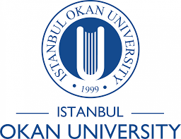

INTERNATIONAL TRADE DEPARTMENT 2024–2025 ACTIVITIES
The primary goals of our department include raising individuals with an entrepreneurial mindset in foreign trade, empowering our students to become competent, visionary, creative, and constructive professionals in the field of international trade, and contributing to their development through courses that integrate real business life into the undergraduate education process.
We aim to cultivate foreign trade awareness by involving our students in various projects and support their professional development through informative field trips that allow them to interact closely with senior executives in the industry.
Within the department, we regularly organize seminars and briefing sessions on current issues, offer qualified internship opportunities, and conduct field visits in collaboration with institutional stakeholders—all of which serve to reinforce the practical skills and sectoral awareness of our students.

Departmental Activities

Election of the 2024–2025 Executive Board of the International Trade Club, Istanbul Okan University, and the First Board Meeting
Date: September 2024
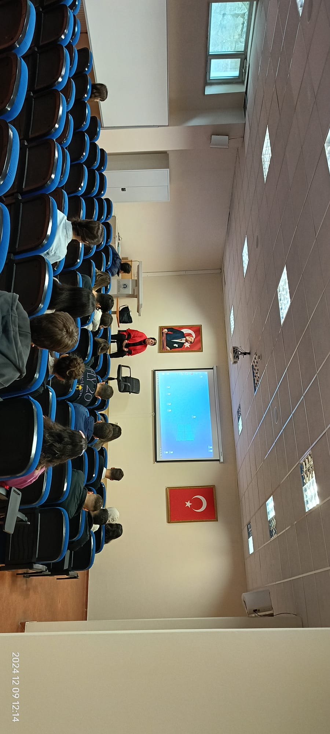
Election Results:
Following the election, Tuana Sude Yalçın, a student of the Logistics Department and also a double-major/minor student in the Department of International Trade, and Anıl Burak Temel, a student in the Department of International Trade, have been elected as Co-Presidents of the International Trade Club.

At the International Trade Club Executive Board Meeting held on February 28, 2025, we planned our upcoming activities and initiatives.
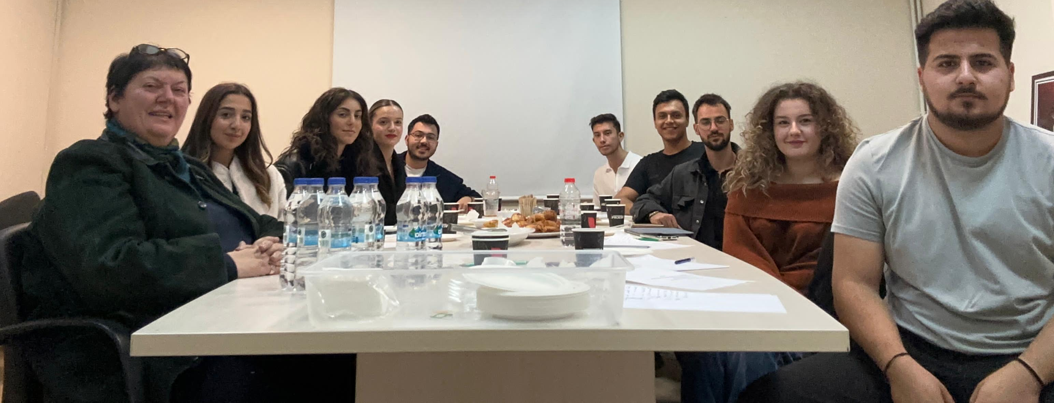

Under the leadership of our Department Chair, we participated in the Turkish Trade Fair held on November 7–9, together with our students as representatives of the Department of International Trade at Istanbul Okan University.

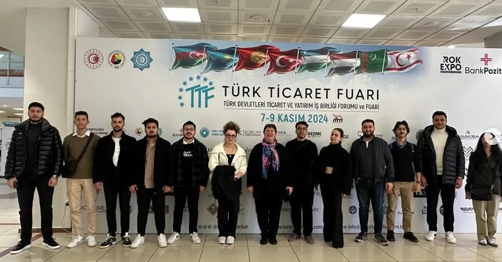

Free Zone Visit by the International Trade Club of Istanbul Okan University
Date: November 2024

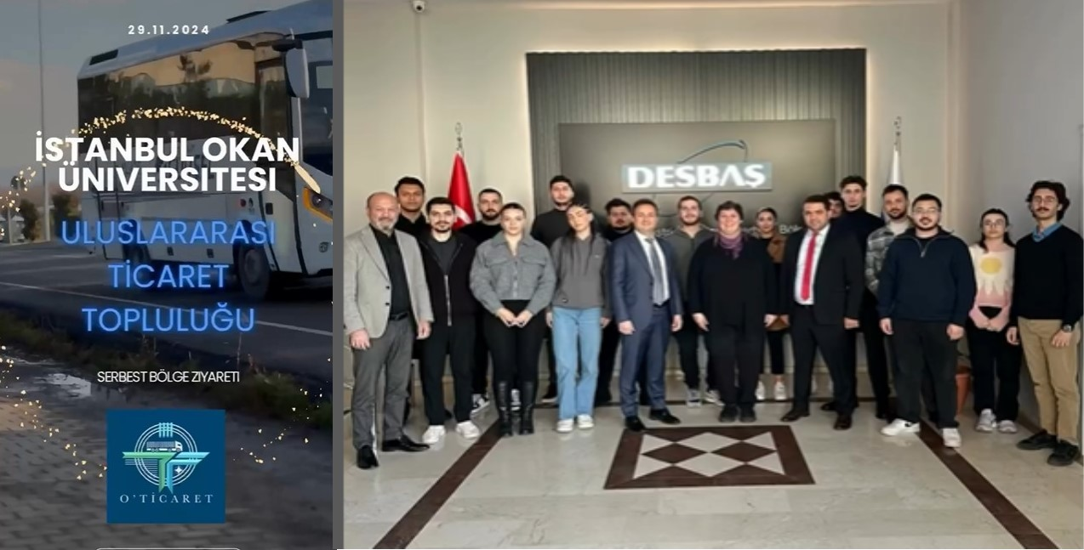

Our Event Titled “A Long and Winding Road from Captaincy to Entrepreneurship” featuring Ms. Ayşe Aslı Başak as Guest Speaker
Date: February 2025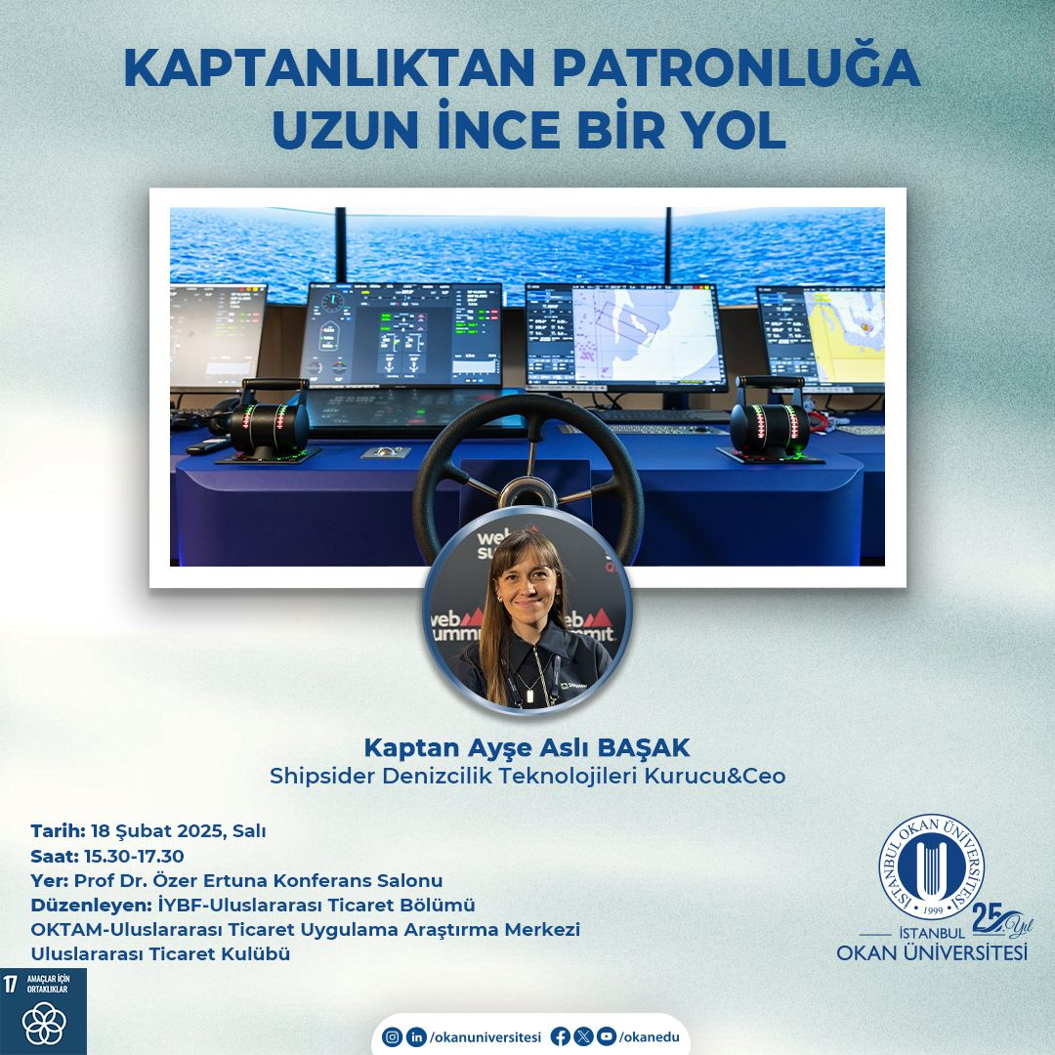
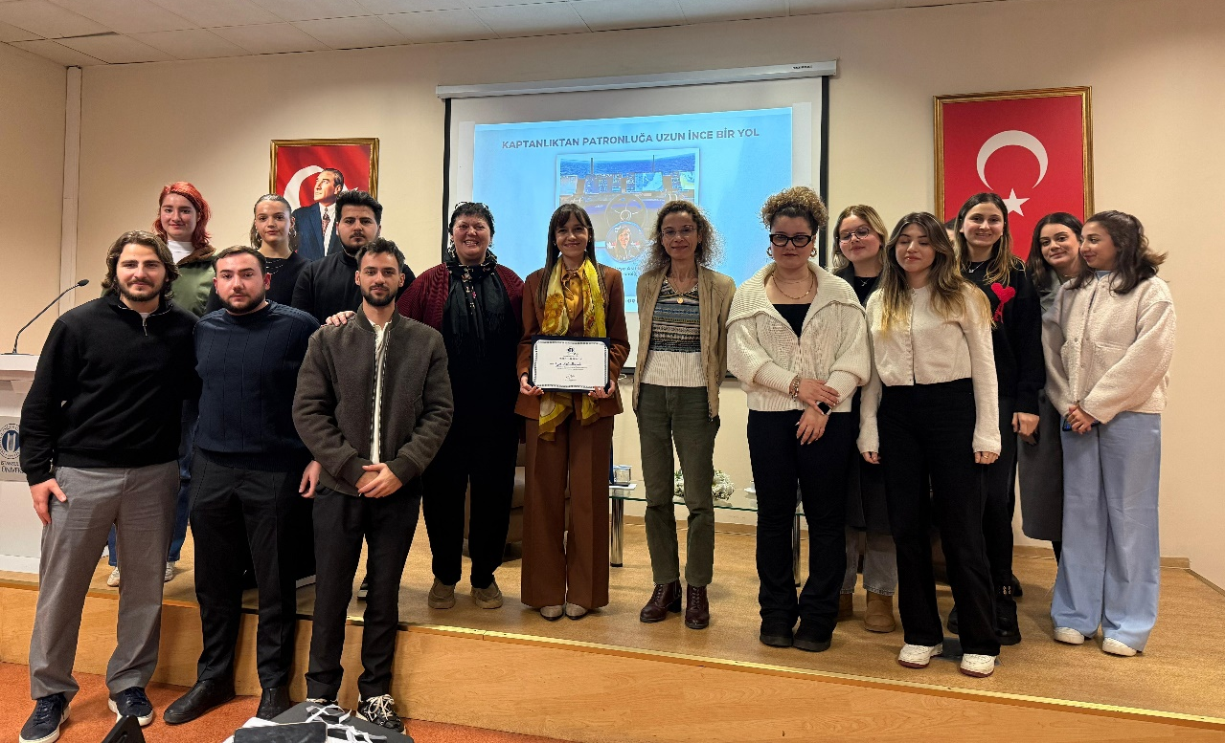
Our Event Titled “Starting with Investment in Export”
Featuring: Mr. Uğur Hasançebi
Date: May 2025
