LOGISTICS MANAGEMENT DEPARTMENT

Dear Students,

At Istanbul Okan University, the English Logistics Management program offers a comprehensive education focused on both technical knowledge and interpersonal skills. Our department places particular emphasis on contemporary topics such as Sustainable and Innovative Logistics and E-logistics.

In addition to core theoretical courses such as Supply Chain Management, Production and Operations Management, Warehouse and Inventory Management, and Transportation Management, students are given the opportunity to study an additional foreign language—German, Chinese, Russian, or Arabic—alongside English.

Through various activities, industry-collaborated projects, internships, and participation in international exchange and Erasmus+ programs, our students are supported in developing key competencies in logistics management.

Moreover, our students benefit from advanced technological learning environments such as the Logistics Classroom, the Business Strategy Laboratory, and the Trademaster Finance Laboratory, which enhance their practical and analytical skills.

Thanks to our strong collaborations with logistics companies, our students benefit from fieldwork and case studies, as well as panels and conferences organized with industry stakeholders. Through contemporary educational approaches such as the O’COOP / COOPerative Learning Workplace Training Program, we support our students’ academic and professional development.

We look forward to welcoming our valuable students who choose the Logistics Management program at Istanbul Okan University. Join us in adding value to one of the most important phases of your life—your university journey—where we aim to learn, grow, and produce together under the guidance of science.

In the 2023-2024 academic year, Assoc. Prof. Dr. Didem Demir conducted Supply Chain Management and Marketing Management courses in collaboration with DHL.

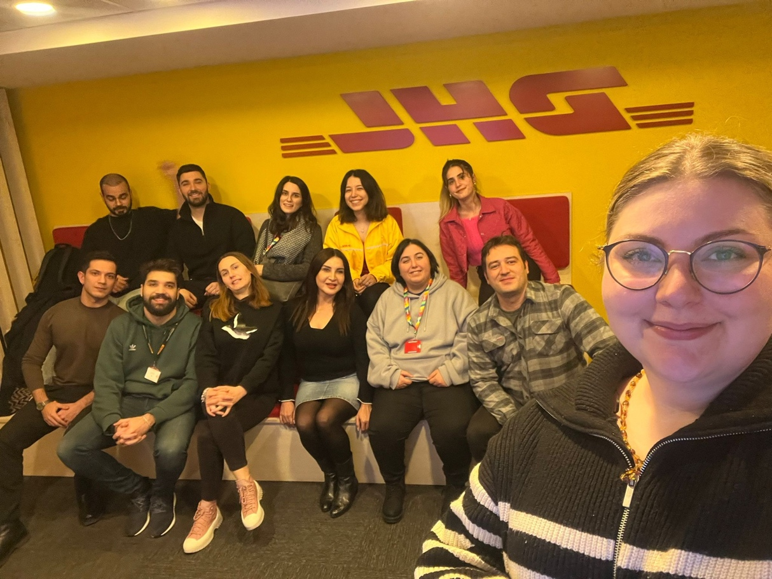

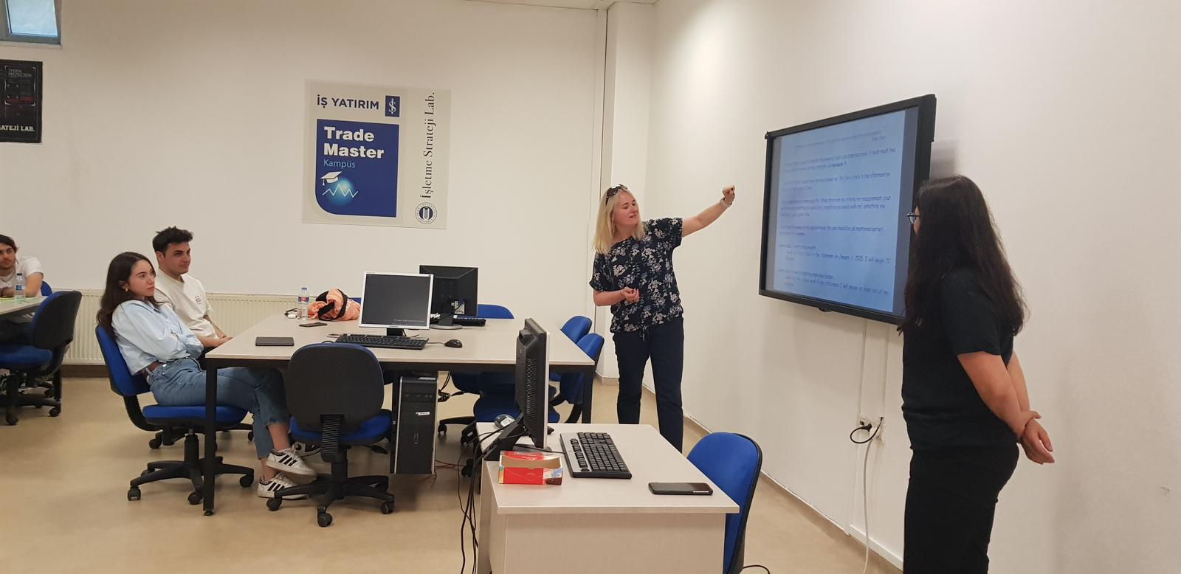

In the 2023–2024 academic year, Dr. Paulina Gajewska from the Faculty of Management and Transport at the University of Bielsko-Biala, Poland, delivered a seminar on Time Management to the students of the Logistics Management Department at Istanbul Okan University.

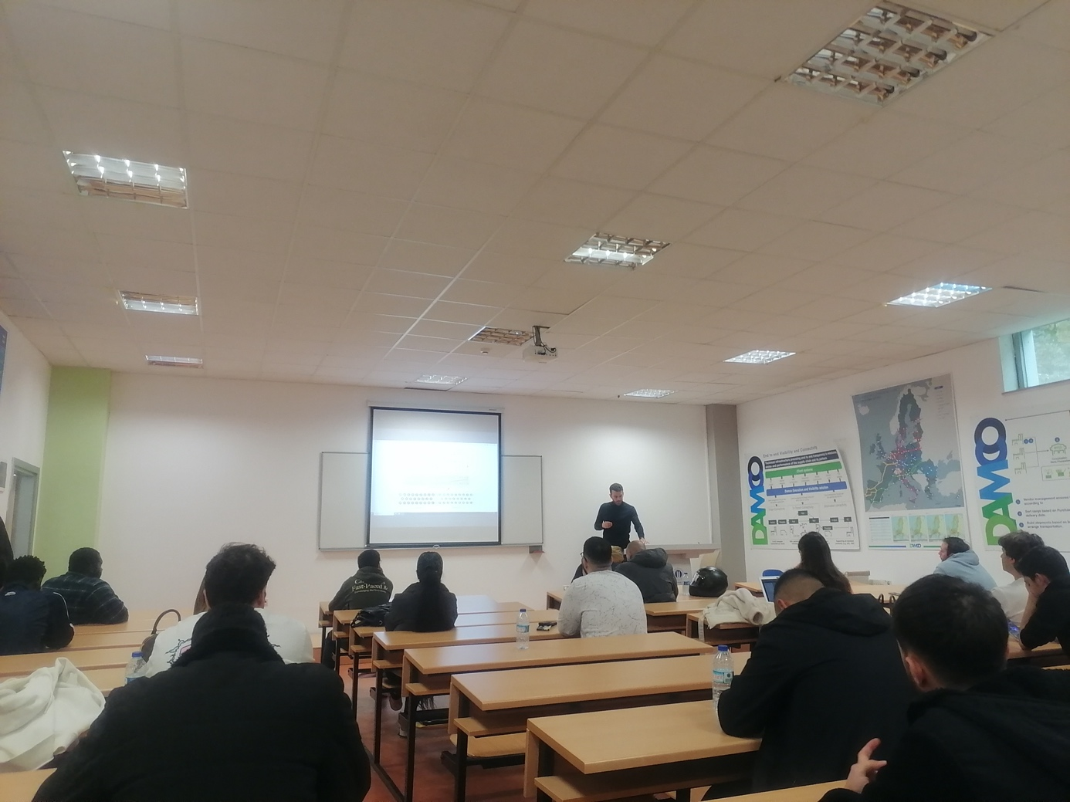

In the 2023–2024 academic year, Yannick Lerusse from the Marketing Department of IESN-Henallux, Luxembourg, delivered a seminar titled “Supply Chain and New Technologies Involved in the Industry” to the students of the Logistics Management Department at Istanbul Okan University.

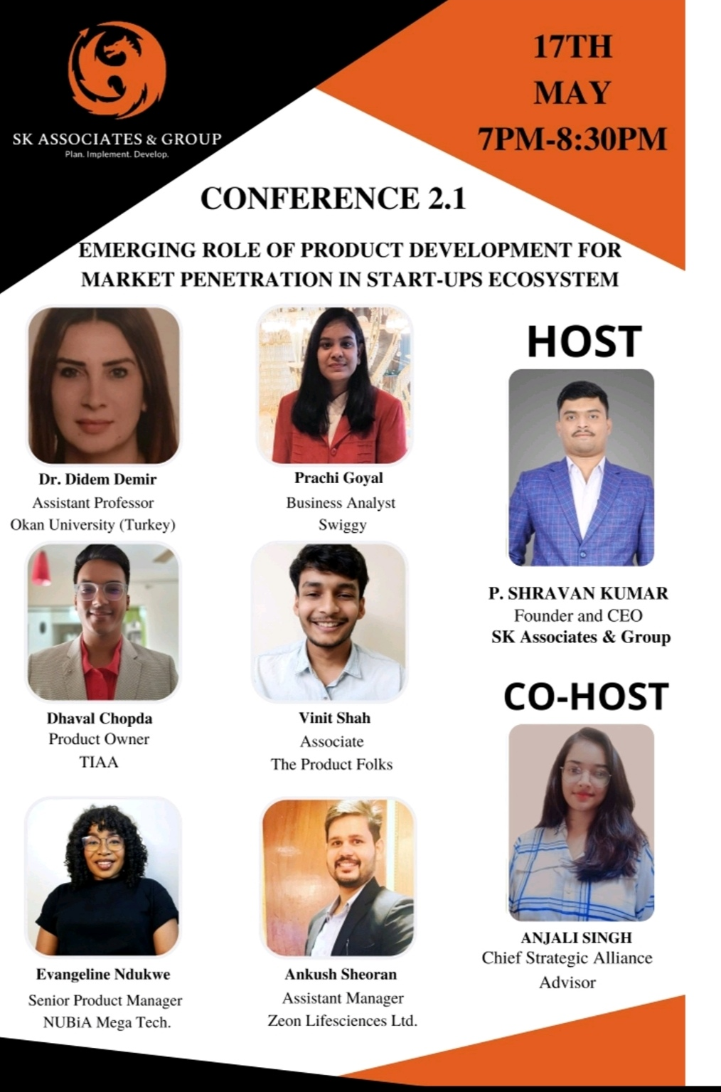
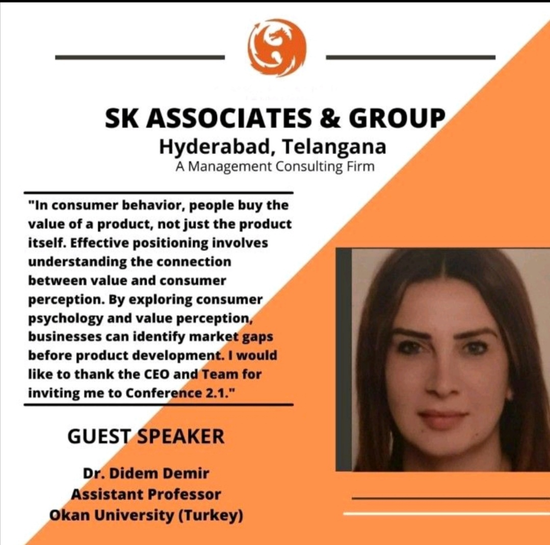

In the 2023–2024 academic year, Assoc. Prof. Dr. Didem Demir, Head of the Logistics Management Department, participated as a guest speaker at the conference titled “Emerging Role of Product Development for Market Penetration in the Start-up Ecosystem”.

Academic Activities (2023–2024)

Yıldız, S. Y & Demir, D. (2023) OYUNLAŞTIRMANIN SATIN ALMA DAVRANIŞINI ŞEKİLLENDİRMEDEKİ GÜCÜ. Toplum Ekonomi ve Yönetim Dergisi, 4(2), 336-358.

DEMİR, D. (2023). A BIBLIOMETRIC ANALYSIS OF CONSUMER PARTICIPATION (1970-2023). Journal of Financial Politic & Economic Reviews/Finans Politik & Ekonomik Yorumlar, 60(665).

DEMİR, D. (2023) ÇEVRESEL, SOSYAL VE EKONOMİK BOYUTLARDA SÜRDÜRÜLEBİLİR E-TİCARET LOJİSTİĞİ. Ekonomik ve Yönetsel Boyutları ile Sürdürülebilirlik, 118.

DEMİR, D. (2023). PAZARLAMA VE LOJİSTİĞİN ENTEGRASYONU ÇERÇEVESİNDE MÜŞTERİ HİZMETLERİNİN ÖNEMİ. Uluslararası Akademik Birikim Dergisi, 6(ÖZEL SAYI).

ULUSLARARASI PAZARLAMA VE KÜLTÜR, Kaynar, Yıldız, Demir (2023), Koç E., Ayyıldız Yazıcı, A. S. (Ed.), Uluslararası Pazarlama, ss.35-68, Seçkin Yayınevi.

