INTERNATIONAL TRADE DEPARTMENT 2023-2024 ACTIVITY REPORT
Istanbul Okan University’s Department of International Trade continues its educational activities in two tracks: Turkish and English.
Our primary aim is to equip our students with a strong foundation that will enable them to succeed in the field of international trade by closely following current trends in buying and selling activities and grasping the essence of the global movement of goods and services in line with the evolving conditions of a changing world.
Our educational approach is enriched with academic content, seminars, informative field trips, and projects to enhance the practical understanding of topics and bring them closer to real business life.
In addition, various initiatives aimed at developing students' competencies such as project preparation, presentation techniques, analytical thinking, and both written and oral communication skills — including the evaluation of their work by business professionals as jury members — help prepare our students for the roles they will undertake in the future.
OUR FACULTY MEMBERS IN THE TURKISH AND ENGLISH TRACKS OF THE INTERNATIONAL TRADE DEPARTMENT

Asst. Prof. Dr. Ayşenur TOPÇUOĞLU
(Department Chair / Head of Department)

Asst. Prof. Dr. İrem YALKI
(Vice Dean, Faculty of Business and Administrative Sciences)

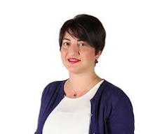

Assoc. Prof. Dr. Aynur PALA
(Head of Graduate Program in International Trade)
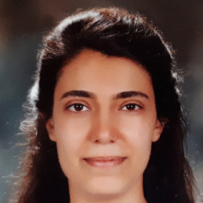
Asst. Prof. Dr. Seda KEKLİK
(Erasmus Coordinator, Department of International Trade)

Research Assistant Ateş EROL

PROVEN SUCCESS
Employer Preference Index
Kariyer.net has analyzed 200 million interactions from 486,000 employer users seeking new hires over the past 10 years and created the Employer Preference Index.
You can find the results for Logistics Management and International Trade & Logistics departments at the following link:
https://www.kariyer.net/en-iyi-universiteler/universiteler-bolumler?dpt=273,754&cp=1
According to the index, Istanbul Okan University’s Department of International Trade ranked second after Boğaziçi University and achieved a remarkable +21 position increase.

CONTRIBUTION TO THE INTERNATIONAL RECOGNITION OF ISTANBUL OKAN UNIVERSITY
As a member of the Service Exporters’ Association, Istanbul Okan University has been entitled to benefit from the Brand Support Program granted by the Ministry of Trade.
Within the scope of this program, our faculty members from the Faculty of Business and Administrative Sciences and the Department of International Trade actively participated in conducting Target Market Analyses for three countries: Morocco, Bangladesh, and Pakistan.

NATIONAL AND INTERNATIONAL PUBLICATIONS

Book Chapters
İrem YALKI
- Yalkı, İrem (2023). A New Economic Model for Sustainability: A Macro Approach to Circular Economy, in Sustainability in Economic and Managerial Dimensions, Eds: İrem Yalkı & Zeynep Alemdar, Istanbul Okan University Press, pp. 11–33.
- Yalkı, İrem (2023). The Share of Renewable Energy in Total Energy Supply: A Case Study of Turkey, in Energy and Environmental Economics in Macro Dimensions, Eds: Burhan Durgun & Funda Durgun, Özgür Publishing, pp. 145–172.

Articles
Aynur PALA
- Pala, Aynur (2024). The Evolution of Commodity Trio Prices and Causality Equation: In Structural Break Perspective, International Journal of Energy Economics and Policy, 14(2), pp. 335–340. (Q2 - Scopus indexed, supported by Istanbul Okan University & TÜBİTAK)
İrem YALKI
- Yalkı, İrem & Akıncılar-Köseoğlu, Nihan (2023). Situation of the Energy Sector in the 100th Anniversary of the Republic: An Analysis of the EU-Turkey Reports, The Academic Elegance, Special Issue for the 100th Anniversary of the Republic of Türkiye, Vol. 10, pp. 372–408. [in Turkish]

Book Editing
İrem YALKI
- A New Economic Model for Sustainability: A Macro Approach to Circular Economy, in Sustainability in Economic and Managerial Dimensions, Eds: İrem Yalkı & Zeynep Alemdar, Istanbul Okan University Press.

CONFERENCES & PRESENTATIONS

Papers Presented
İrem YALKI
- Şahin, Özgür & Yalkı, İrem (2024). The Impact of Primary, Renewable, and Total Energy Consumption on GDP in BRICS Countries and Turkey: A Panel Data Analysis (1992–2021), The Economic Research and Financial Markets Congress, 9–11 May 2024, Mersin.
Aynur PALA
- Pala, Aynur & Bouchafaa, Bahia (2024). Energy-Food Commodity Prices Movement and Equation in Kyoto (2006) Perspective: Factor Analysis and Non-Linear Framework, International Conference on Energy Economics and Energy Policy (ICEEEP 2024), 27–29 April 2024. (Scopus indexed)
- Pala, Aynur (Accepted). Technology-Growth Nexus in OECD Countries: Evidence from Panel ARDL Model, International Conference on Knowledge Economy 2024 (ICKE24), 22–23 August 2024.

THESES AND PROJECTS SUPERVISED
İrem YALKI
- PhD Thesis: SERKAN CEBELLİ – Istanbul Okan University, Business Administration (English), Forecasting the Electric Vehicle Stock in the Turkish Market.
Aynur PALA
- Supervising two theses under the International Trade (English) Master’s Program:
  - Exploring the Nexus of Food Speculation and Market Financialization in Commodity Trading
  - Sustainable International Trade
- Completed 2 thesis projects in the Business Administration Program in 2023.
Ayşenur TOPÇUOĞLU
- Master’s Thesis: CÜNEYT İYİBİLİR – Istanbul Okan University, International Trade Master’s Program: Foreign Trade in Turkey’s Yarn Industry: Problems and Solution Proposals, January 2024.

EXPORT PROJECT
In a project setting evaluated by business professionals as jurors, our students present selected products and demonstrate how and where they would export them.
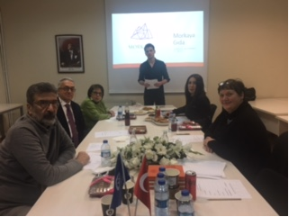

PROFESSIONAL AFFILIATIONS
Assoc. Prof. Dr. Aynur PALA
- Member of the Content Committee, Capital Markets Congress, organized by TSPB and Capital Markets Board of Turkey (SPK)
- Member of the Technical Committee, ICEEEP – International Conference on Energy Economics and Energy Policy
- Member of the Technical Committee, ICACER – International Conference on Advances on Clean Energy Research
- Member of IPAMA – Institute of Price Analysis and Marketing for Agricultural and Food Products, Agricultural University of Athens
- Member of the Executive Board, Faculty of Business and Administrative Sciences
- Member of the Executive Board, Faculty of Law
- Member of the Executive Board, Faculty of Humanities and Social Sciences
Asst. Prof. Dr. Ayşenur TOPÇUOĞLU
- Auditor Board Member, WILAT Global (Women in Logistics and Transport – Turkey)
- Executive Board Member, ARPROGED – Istanbul Okan University Research Project Development Directorate
Asst. Prof. Dr. İrem YALKI
- Assistant Editor, Journal of Finance, Political and Economic Comments
- Member of the Executive Board, Faculty of Business and Administrative Sciences

CONTRIBUTIONS TO RESEARCH AND APPLICATION CENTERS
Assoc. Prof. Dr. Aynur PALA
- Contributed to the establishment process of a "Sustainability and Innovation Center" within the Faculty of Business and Administrative Sciences, in cooperation with Development and Investment Bank of Turkey and Istanbul Okan University.
Asst. Prof. Dr. Ayşenur TOPÇUOĞLU
- All events organized by the department and student club (e.g., Halı Trade Fair, Family Business Management, Sustainable Leadership Programs) were carried out in collaboration with the International Trade Practice and Research Center.
Asst. Prof. Dr. İrem YALKI
- Presented at the "Launching Event of SES Lab (Sustainable Economic Systems)" on October 26, 2023, with a talk on “Sustainability in Turkey’s Energy Sector in the 100th Anniversary of the Republic”.

SEMINARS AND STUDY VISITS ORGANIZED
- December 5, 2023 – Department of International Trade Student Club
Seminar Title: Sustainable Leadership: Export Strategies of Next-Generation Managers in Family Businesses
Guest Speaker: Kerim Can Ertuğ
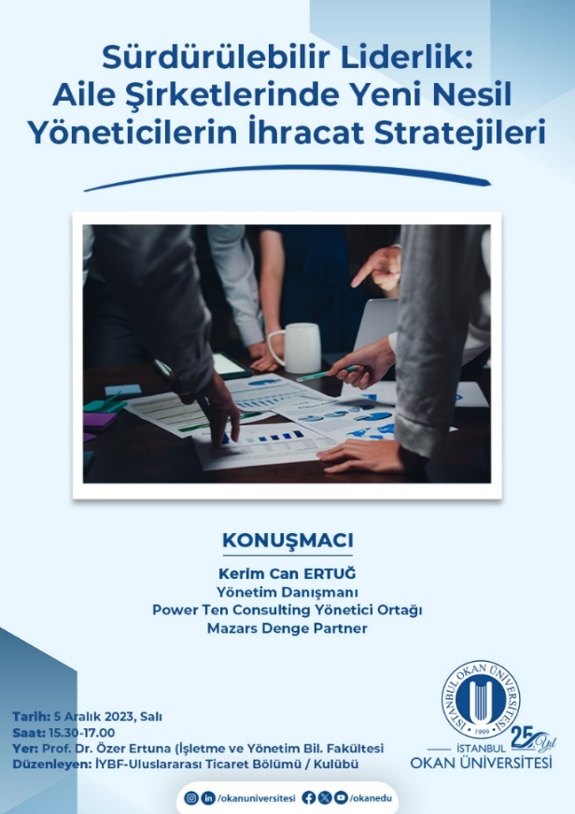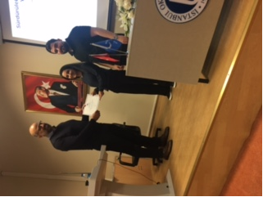
December 8, 2023 – Carpet and Flooring Fair (CFR Carpet and Flooring Expo)
Location: Istanbul Expo Center, Yeşilköy – Istanbul

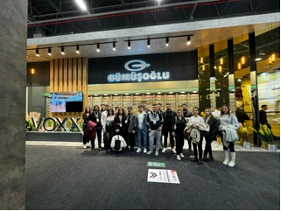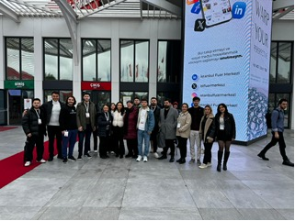

Asst. Prof. Dr. Ayşenur TOPÇUOĞLU-Member of the Organizing and Promotion Committee, 6th Turkey-China Economic Forum
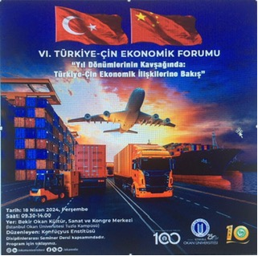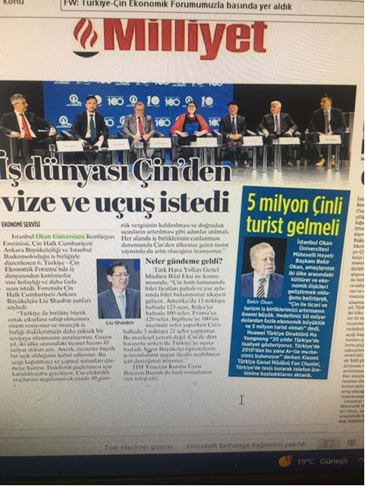

SUPPORT FOR PROMOTIONAL ACTIVITIES
- March 6, 2024 (Wednesday)
As part of the International Trade course, students from five high schools attended the class, actively engaging by asking questions and gaining insights into the field of international trade.
- May 8, 2024
Asst. Prof. Dr. Ayşenur TOPÇUOĞLU participated in a high school promotional activity at Sultanbeyli Anatolian High School.
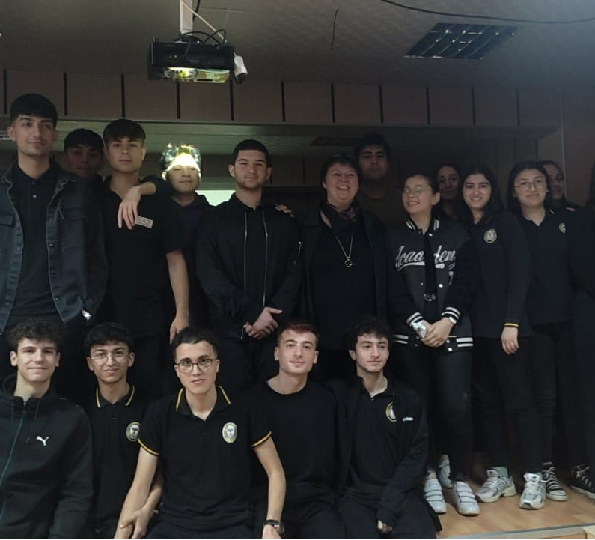

STUDENT ACHIEVEMENTS
In the 2023–2024 academic year, a total of 27 students graduated from the Department of International Trade.
- Second Highest GPA in the Faculty: Sezgin Maden (International Trade – Turkish Program)
- Third Highest GPA in the Faculty: Sarya Şahin (International Trade – Turkish Program)

Honor Students
International Trade – Turkish Program:
- Sezgin Maden
- Sarya Şahin
- Pınar Akyıldız Lüleci
- Beril Ünsal
- Avni Erdoğan
International Trade – English Program:
- Tuğçe Keskin
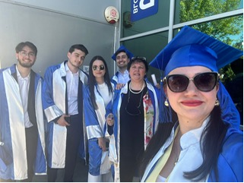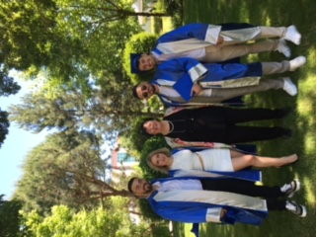

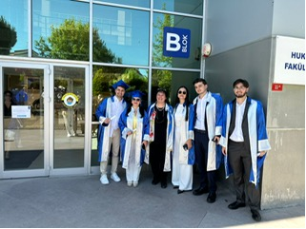

COOP PROGRAM STUDENTS
Advisor: Asst. Prof. Dr. İrem YALKI
International Trade – Turkish Program
- Sezgin Maden
- Sarya Şahin
- Emine Ezgi Polat
- Busenur Anlar
- Nurullah Dursun
- Muhammet Ali Yazıcı
International Trade – English Program
- Can Muhammed Özel
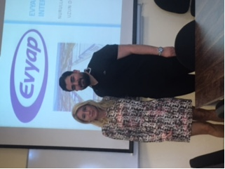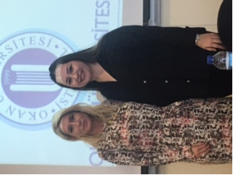

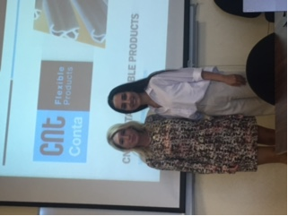

INTERNSHIP COMPLETIONS
A total of 19 students from both the Turkish and English tracks of our department successfully completed their internships during the 2023–2024 academic year.

ERASMUS PROGRAM SUCCESS
3 students from both the Turkish and English programs were accepted into the Erasmus Exchange Program for the 2023–2024 academic year.

STUDENT CLUB ACTIVITIES
International Trade Club
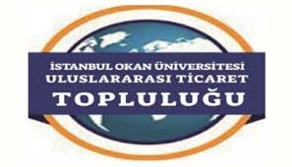

CLUB LEADERSHIP
International Trade Club
- Co-Presidents: Sarya Şahin, Nurullah Dursun
- Faculty Advisor: Asst. Prof. Dr. Ayşenur TOPÇUOĞLU
- Executive Board Members:
  - Sezgin Maden
  - Ezgi Polat
  - Beril Ünsal
  - Avni Erdoğan
  - Salim Demir
  - Nafi Kuloğlu

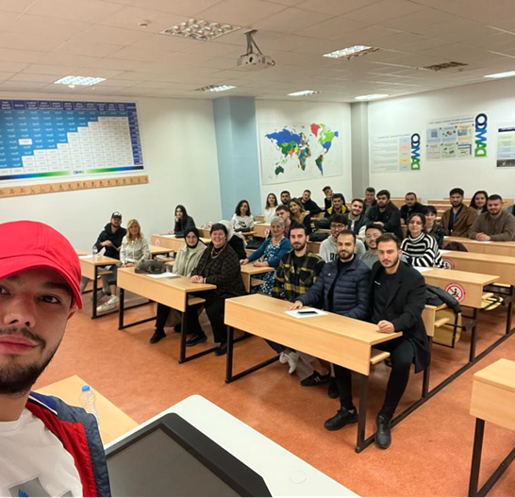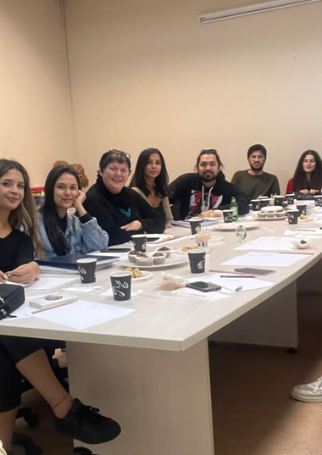

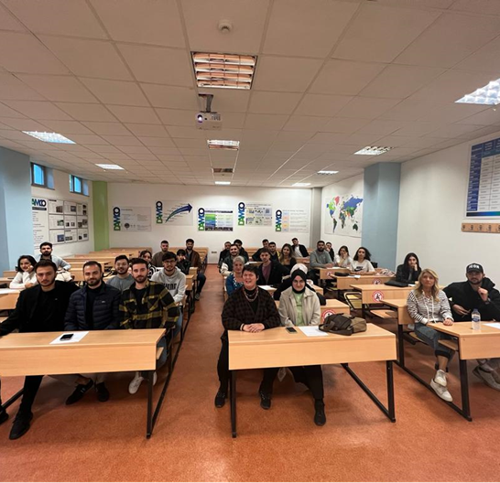
Polar Research Club
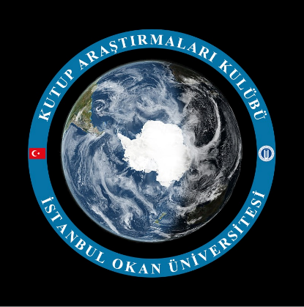
Club Leadership: Berke Can Dölek, Merve Keser
Faculty Advisor: Asst. Prof. Dr. İrem YALKI
